**--**



**“****Web Based System for Gym Workout Calories Burnt Prediction”**

By:

**Shaul Hammed Mohammed Sajith**

**St20253338**

**CL/BSCSD/24/64**

**A PROJECT SUBMITTED TO**

**INTERNATIONAL COLLEGE OF BUSINESS AND TECHNOLOGY (ICBT)**

**IN PARTIAL FULFILLMENT OF THE REQUIREMENTS FOR THE**

**Bachelor of Science (Hons)**

**BSC (Hons) Software Engineering**

**Declaration**

Statement of originality of submitted work.

Shaul Hameed Sajith

Student ID – st20253338 (CL/BSCSD/24/64)

Here by confirm that the work presented here in this report, and in all other associated material, is my own work, and I agree to assessment for plagiarism.

Signature – Sajith

Date – 18/10/2023

# **Acknowledgement**

I would like to extend my sincere appreciation to the instructor, Mr. Shamirad, for all of his help in making this project a success. I was able to perform in-depth research under his direction and gain a significant amount of fresh knowledge in the field of contemporary knowledge and technology. In addition, I want to express my gratitude to my parents and friends for their continuous support and encouragement. These people have been a constant source of inspiration for me as I work to accomplish my goals.

# **Abstract**

"Due to busy schedules and shifting lifestyle demands, people frequently find it difficult to keep track of their health and fitness in today's fast-paced environment. Understanding the quantity of calories burned during physical activity or workouts is important for keeping a healthy lifestyle. A web-based calorie prediction system is created to fill this demand by calculating how many calories a user will burn while exercising. This system is dependent on a number of factors, including the user's age, weight, gender, and exercise session length and intensity. The rising obesity epidemic in today's culture emphasises the significance of keeping an eye on calorie intake and usage. A serious health problem impacting individuals all around the world is obesity. The solution is to create a web-based system for gyms that would allow users to monitor how many calories they burn while engaging in exercise. The major goal of this study is to analyse and explore various machine learning methods for determining the number of calories burned during physical activity.

In this investigation, a machine learning system will be created with the express objective of figuring out how many calories are burned during exercise. This algorithm will consider a number of variables, such as the workout kind, user attributes, and exercise length. The purpose is to give people a thorough grasp of how their physical activity affects their calorie balance.People are becoming more interested in other people's activities and lifestyles as well as their own health and fitness in today's connected society. Regression approaches in particular can be used to address the issue of accurately calculating calorie consumption during physical activity. These techniques will give consumers insightful information about their food and exercise regimens, ultimately encouraging better lifestyles.

Table of Contents

**Acknowledgement** 3

**Abstract** 3

**Chapter 1-Introduction** 8

**1. 1 Problem Statement** 8

**Future problems might come up:** 8

**1.2 Literature review** 9

**1.3 Objects of the Project** 10

**1.4 RESEARCH QUESTION** 10

**1.5** **RESEARCH OBJECIVES** 10

**Techniques Proposed:** 11

**1.6 The Project's Scope** 12

**Project Outcomes** 12

**1.7 Project's Limitations** 13

**1.8 SIGNIFICANT OF THE STUDY** 14

**1.9 DESIGN OVERVIEW** 15

**1.10** **WBS – Work Break Down Structure** 17

**Chapter2- Literature Review** 18

**Dependent and Independent Variables** 18

**2.1** **DEPENDANT VARIABLE** 19

**2.2** **INDEPENDENT VARIABLE** 21

**2.3 MODERATING VARIABLE** 22

**2.4 UNDERLYING THEORY** 23

**2.5 GAPS IN LITERATURE REVIEW** 23

**2.6 HYPOTHESIS DEVELOPMENT** 23

**Chapter3-Methodologies for Software Development** 25

**3.1THEORITICAL FRAMEWORK** 25

**3.2** **POPULATION** 25

**3.3** **RESEARCH APPROACH** 26

**3.4** **MEASURES AND INSTRUMENTS** 27

**3.5** **DATA COLLECTION** 27

3.6 DATA ANALYSIS 30

**Chapter 4 – Background of the Study** 33

**4.1Why Is It?** 33

**4.2** **What Is the Importance of It?** 33

**4.3** **All User Requirements List** 33

**4.4** **EXPLANATION OF THE CURRENT SYSTEM** 33

**Current System's Strengths:** 34

**4.5 DREW BACKS OF THE CURRENT SYSTEM** 34

**4.6** **EXPLANATION OF THE PROPOSED SYSTEM** 35

**Chapter 5 –Feasibility Study and Requirements Gathering** 36

**5.1 Feasibility Studies** 36

**5.1.2 COST FEASIBILITY** 36

**5.1.3** **Feasibility of Time Management** 37

**5.1.4 SCOPE FEASIBILITY** 38

**5.1.5 Technical Feasibility** 38

**5.2 Requirements Gathering** 39

5.2.1 SELECTING THE SUITABLE FACT GATHERING TECHNIQUE 39

**5.2.3 REQUIREMENTS DETERMINATION** 40

5.2.3.1 CORE REQUIREMENTS: 40

5.2.3.2 SECONDARY REQUIREMENTS: 40

**5.2.4 RESOURCE IDENTIFICATION** 41

5.2.4.1 Hardware Requirements 41

5.2.4.2 Software Requirements 41

**5.2** **THE SOFTWARE PROCESS MODEL** 41

**CHAPTER 6: DOMAIN INVESTIGATION** 43

6.1 DECISION SUPPORT TOOLS 43

Why it is important 43

**6.1.2** **DECISION THEORY** 44

**6.1.3 DECISION TREE** 45

**6.2** **TECHNICAL RESEARCH** 46

**Chapter 7 – Design** 47

**1.** **System Design - Architecture** 47

**7.3 Database Development** 58

**7.3.1 Entity Relationship – ER Diagram** 60

**Chapter 8 – Implementation** 61

**1.** **System Implementation** 62

**2.** **UI Implementation** 65

**Login / Registration Page UI** 66

**Prediction Page UI** 68

**Result Page UI** 70

**4. Model Implementation** 71

**Dataset Details** 72

**Chapter 9 –TESTING** 75

9.2 TEST PLAN AND TEST CASES 75

**Chapter 10 – Critical Evaluations & Conclusion** 79

**10.overweview of maintain** 79

**10.1. Summary** 81

**10.2. Evaluation** 81

**10.3 Limitation of the system** 82

**10.4. Future enhancements** 82

10.5 LESSONS LERANED REPORT 82

**10.6. Conclusion** 83

**Chapter-11 REFERENCE** 83

APPENDIX A: REFERENCE 83

References 83

**APPENDIX B**: **USER MANUAL** 84

**APPENDIX C: PROJECT LOG SHEETS** 87

**Table of figure**

**Figure 1: WBS** 16

**Figure2: Conceptual Framework** 17

Figure 3-Google form 28

**Figure 4: Login Sequence Diagram** 49

**Figure 5: Registration Sequence Diagram** 50

**Figure 6: Calories Sequence Diagram** 51

**Figure 7: Class Diagram** 52

**Figure 8: ER Diagram** 53

**Figure 9: Context Diagram** 54

**Figure 10: Graphical Context Diagram** 55

**Figure 11: Home Wireframe** 56

**Figure 12: Login Wireframe** 57

**Figure 13: Registration Wireframe** 57

**Figure 14: Result Wireframe** 58

**Figure 15: Prediction Wireframe** 58

**Figure 16: XAMPP Server** 59

**Figure 17: Database Connection CodeFigure 18: XAMPP Server** 59

**Figure 19: Database Connection Code** 60

**Figure 20: Registered DetailsFigure 21: Database Connection Code** 60

**Figure 22: Registered Details** 60

**Figure 23: Database Table DetailsFigure 24: Registered Details** 60

**Figure 25: Database Table Details** 61

**Figure 26: Implementation FolderFigure 27: Database Table Details** 61

**Figure 28: Implementation Folder** 62

**Figure 29: Implementation Code 2Figure 30: Implementation Folder** 62

**Figure 31: Implementation Code 2** 63

**Figure 32: Implementation Code 1Figure 33: Implementation Code 2** 63

**Figure 34: Implementation Code 1** 63

**Figure 35: Implementation Code 4Figure 36: Implementation Code 1** 63

**Figure 37: Implementation Code 4** 64

**Figure 38: Implementation Code 3Figure 39: Implementation Code 4** 64

**Figure 40: Implementation Code 3** 64

**Figure 41: Home Page UIFigure 42: Implementation Code 3** 64

**Figure 43: Home Page UI** 65

**Figure 44: Home Page CodeFigure 45: Home Page UI** 65

**Figure 46: Home Page Code** 65

**Figure 47: Login Page UIFigure 48: Home Page Code** 65

**Figure 49: Login Page UI** 66

**Figure 50: Registration UIFigure 51: Login Page UI** 66

**Figure 52: Registration UI** 66

**Figure 53: Registration / Login UI CodeFigure 54: Registration UI** 66

**Figure 55: Registration / Login UI Code** 67

**Figure 56: Prediction PageFigure 57: Registration / Login UI Code** 67

**Figure 58: Prediction Page** 68

**Figure 59: Prediction Page UI CodeFigure 60: Prediction Page** 68

**Figure 61: Prediction Page UI Code** 69

**Figure 62: Result Page UIFigure 63: Prediction Page UI Code** 69

**Figure 64: Result Page UI** 70

**Figure 65: Result Page UI CodeFigure 66: Result Page UI** 70

**Figure 67: Result Page UI Code** 70

**Figure 68: Dataset AnalyzingFigure 69: Result Page UI Code** 70

**Figure 70: Dataset Analyzing** 73

**Figure 71: Correlation HeatmapFigure 72: Dataset Analyzing** 73

**Figure 73: Correlation Heatmap** 73

**Figure 74: Training the DatasetFigure 75: Correlation Heatmap** 73

**Figure 76: Training the Dataset** 74

**Figure 77: Testing the DatasetFigure 78: Training the Dataset** 74

**Figure 79: Testing the Dataset** 74

**Figure 80: Testing the Dataset** 74

# **Chapter 1-Introduction**

Weight loss, gain, or maintenance are all strongly tied to daily energy consumption. If a person wishes to lose weight, he or she must create a calorie deficit (burn more energy than they consume). Nonetheless, people need to be conscious of how many calories they take in each day. The majority of people think that the best unit of measurement for diet and weight loss is calories. There are several ways to define a calorie: as heat or as a unit of energy. The number of calories in a gramme (g) of water is the amount of energy needed to elevate it by one degree Celsius. A few power-releasing systems outside of the living organism might make use of such statistics.

The amount of energy required by Calories are used to measure how well the human body functions. Anyone who wishes to accomplish and maintain an active lifestyle, lose weight, or gain weight must understand how many calories they burn each day.If one is aware of the variables that affect calorie burning, they can modify their diet or exercise regimen to help them lose weight. Numerous factors influence how many calories are expended each day. Some of the variables that impact daily calorie burn cannot be changed, but others can. Among these reasons is the fact that as people age, they consume less calories per day. Men consume more energy than women.

Consistent exercise level: Body composition: People who have more muscle than fat in their body burn more calories. Body mass index: Larger individuals burn additional calories than those who are smaller, particularly when at rest. The energy needed by our bodies to break down food is referred to as thermogenesis. Users may quickly and easily track their physical activity levels with the help of the web-based calorie prediction system, which can help them accomplish their fitness objectives and maintain a healthy lifestyle. This essay will examine this technology's salient features, advantages, drawbacks, and possible developments in the future.

## **1. 1 Problem Statement**

Understanding the problem and developing system software to address the underlying issue are the major goals of a problem statement. With the gym's success and membership increasing, a critical issue—the lack of an automated system for tracking calories burned—has surfaced. A web-based calorie estimating system that is integrated with cardio and exercise equipment is necessary given the growing trend of using technology to monitor and track fitness goals. To achieve their fitness goals, many people use machines like treadmills, ellipticals, or stationary bikes, and they often rely on internet tools to track their progress.

The major goals of problem analysis are to understand the issue and to evolve its system software to address the revealed underlying cause. As this gym grows in membership and success, it is concerned that there is no automatic mechanism to compute calories burned.

* Because most individuals are extremely busy after working out, users will need to spend extra time manually calculating the calories burned.
* After exercise, people are less aware of how many calories they are taking in.
* They are unable to keep tabs on and record data pertaining to calories.
* People frequently forget to accomplish chores that they intended to finish. For instance, a person can unintentionally forget to keep track of how many calories they burn after exercising.

## **Future problems might come up:**

* **Accuracy**: Due mostly to the reliance on self-reported data, the accuracy of calorie estimating software can be a significant difficulty. Users might not be completely honest with their responses, which could lead to inaccurate calorie calculations because they might under- or overestimate their levels of activity.
* **Data integrity**: Another potential concern is data quality. The accuracy of the calorie projections is affected by the quality of the data used to construct them. If the tool is based on outdated or insufficient nutritional data
* **• User Engagement:** Even if the technology is precise, it might be challenging to keep users engaged. Users may lose interest in tracking their eating and exercise habits over time, resulting in inaccurate or missing data.
* **Inadequate customization:** The inflexibility of web-based calorie prediction tools could be a disadvantage. various individuals may have various needs and objectives when it comes to tracking their meals and exercise.

## **1.2 Literature review**

1. In recent years, there has been an increase in the market availability of health-related applications. These programmes provide a wide range of features and are intended to meet a variety of health and wellness requirements. They are becoming increasingly popular and useful not only to individuals but also to society as a whole.According to a survey, a sizable majority of the population, particularly 65.5% of those polled, use health applications on a daily basis. This statistic demonstrates the rising reliance on technology for health management and monitoring. Furthermore, 44.4% of respondents stated that they normally use these apps for a short period of time, namely one to ten minutes every day. One of the most common use for these health-related apps is to track and regulate eating habits. Users can enter data about the foods they eat, which allows the app to generate and analyse nutritional data. This function is beneficial for people who are concerned about their nutrition and wish to live a balanced and healthy lifestyle. It allows users to track macronutrients, measure calories, and obtain insights into their dietary choices. (Krebs & Duncan, 2019)
2. Some people who get services from particular organisations are sceptical that employing mobile applications will offer them with major benefits. Their scepticism stems from the assumption that in order to benefit from these apps, one must be comfortable and knowledgeable with mobile devices. This perceived demand for mobile device competency has, in turn, had a negative impact on the overall quality of their use of these applications. Despite this scepticism and potential uneasiness with mobile devices, there is a societal trend in which an increasing number of individuals are incorporating health-related apps into their everyday routines. These applications have been shown to provide concrete advantages and have a favourable impact on the general well-being of those who use them. While there may be some initial doubts, the rapid popularity of health-related apps reveals that they do, in fact, offer significant benefits and have the potential to improve the lives of those who use them. (Kumar, 2021)

## **1.3 Objects of the Project**

"The main goal of the proposed effort is to develop a web-based application aimed at improving the performance of the system. This will be accomplished by incorporating a machine learning system made to forecast calorie expenditure across different activities for different people. Furthermore, a thorough investigation and assessment of the current system will be part of this research.

* To accurately anticipate calorie expenditure based on the type of exercise.
* This system will be useful in tracking a person's calories and creating a report.
* By specifying a post-workout time, this system will prompt users to keep track of their calorie consumption.
* • The application is going to become more user-friendly, trustworthy, quick and easy, and intelligent by responding to the system's requirements.

## **1.4 RESEARCH QUESTION**

**Model Accuracy and Improvement:**

* How can the accuracy of calorie burn forecasts be increased, particularly for those with unusual traits or activities?
* Are there any machine learning algorithms or strategies that outperform others in properly estimating calorie burn?

**Data Security and Privacy:**

* Given the sensitivity of health-related information, what safeguards can be put in place to maintain the privacy and security of user data?
* How can you strike a compromise between gathering enough data to make accurate forecasts and protecting user privacy?

**User Motivation and Engagement:**

* What features or design elements can increase user interest and incentive to routinely utilise the calorie prediction system?
* Can gamification or social interaction components be used to motivate people to keep active and manage their calories?

**User Variety and Inclusion:**

* How can the system accommodate users with varying needs, such as those with varying exercise levels, food choices, or medical conditions?
* What steps can be taken to make the system inclusive and accessible to a diverse variety of users

**Real-time Feedback and Behaviour Change:**

* Can real-time calorie burn feedback affect user behaviour and encourage better choices throughout the day?
* What tactics can be used to assist users in changing their behaviour in response to calorie burn data?
  1. **RESEARCH OBJECIVES**

1. **Improve Prediction Accuracy**

Improve the accuracy of calorie burn forecasts through developing and refining machine learning algorithms, particularly for various user profiles and activities.

1. **Research Privacy Measures**

Investigate and implement strong data privacy and security mechanisms to protect user data while retaining system functioning and utility.

1. **Enhance User Engagement**

Identify design aspects and features that boost user engagement and motivation to use the calorie prediction system on a regular basis.

1. **Customize the User Experience**

Implement algorithms and user interfaces that deliver a personalized experience by taking individual parameters like age, gender, and body composition into account.

1. **Integration and Data Sources**

To improve the accuracy and ease of calorie burn tracking, investigate and integrate wearable fitness devices and new data sources.

1. **Behavioral Insights**

To provide insights on how users might make healthier choices, analyses user behavior patterns and their impact on calorie balance.

## **Techniques Proposed:**

* **"Personalise the advice:** In order to address the problem of giving generic advice, the system is capable of giving individualised recommendations by taking into account the user's fitness level, physical characteristics, age, and other pertinent factors. Additionally, it can analyse the user's fitness objectives and offer tailored advice to assist in achieving those objectives.
* **Improve the user interface:** The user interface of the system might be improved to give off a cozier vibe. Users may benefit from easier navigation and a cleaner UI. Additionally, it can provide users with feedback on their fitness development, including tracking patterns in calorie intake and weight loss.
* **Improve Accuracy:** It is possible to fix the problem of inaccurate calorie estimation by enhancing the machine learning algorithms of the system. Creating new algorithms or altering current ones can help algorithms improve their accuracy.

## **1.6 The Project's Scope**

The end result will be the creation of a strategy for improvements and a model that will improve calorie expenditure projections for all clients. Fitness centers may make complaints about this system's use for customer-related activities. The system administrator and the users themselves will be the principal users of this system. The number of calories burned will be entirely at the control of the users and will be determined by the information they provide into the system. The final results, which can be kept and afterwards generated as a report for individual reference, will satisfy all users. Our algorithm will boost user confidence and convenience by automatically producing consistent results as opposed to depending on a human process.

## **Project Outcomes**

* A simple and intuitive user interface for simple navigation.
* All users have access to the system.
* Users can choose to register with the system.
* Users can keep an eye on their caloric consumption each day.
* The system has the ability to log calorie information and generate a summary.
* Users may receive notifications or reminders at different points throughout the system.

## **1.7 Project's Limitations**

These limitations must be overcome by meticulous design, testing, and continuing monitoring to guarantee that the system gives clients accurate, useful, and secure forecasts.

* **Accuracy**: The quality of the data used to generate predictions has an impact on the system's precision. The accuracy of the anticipated calorie expenditure can be affected by a number of variables, including workout intensity, weight, and metabolic rate.
* **User Error:** The accuracy of the system is also influenced by the data that users enter. Incorrect or partial data input can reduce the accuracy of the anticipated calorie burn.
* **Equipment limitations:** The approach relies on the precision and availability of data about exercise equipment, which might not be true for all types of machines or might vary between machines.
* **Calorie Predictions Algorithm:** Because of differences in body composition, exercise preferences, and medical concerns, the algorithm's predictions may not apply to everyone.
* **User Adoption:** Adherence to the recommended training routines and system adoption are critical to the system's effectiveness. Elements such as the system's usability, the accuracy of the recommendations, and the rewards users experience from utilizing the system can all have an impact on user motivation and engagement.
* **Privacy and protection:** The system may gather and retain sensitive user information, such as preferences for fitness and health. To protect user data, it is essential to make sure the system has sufficient privacy and security measures in place.
* **Technical Issues**: Technical issues like as server outages, software faults, and compatibility issues can have an influence on the system's usability and dependability.

## **1.8 SIGNIFICANT OF THE STUDY**

The importance of your web-based calorie burn prediction system project resides in its potential to improve people's health and well-being while also improving the field of health and fitness technology. Here are a few essential elements underlining the importance of your research:

1. **Health Improvement:** By providing a tool to measure and manage calorie consumption and expenditure, your system can empower individuals to take charge of their health. This may lead to healthier lifestyle choices and, as a result, a lower risk of numerous health issues such as obesity, diabetes, and cardiovascular disease.
2. **Personalised Guidance:** By taking into account individual parameters such as age, gender, body composition, and amount of exercise, your system may provide personalised advise and recommendations. This personalisation has the potential to dramatically improve the effectiveness of health management techniques.
3. **Real-time calorie burn input can** operate as a behavioural incentive, pushing users to be more physically active and make better nutritional choices. This behavioural adjustment has the potential to have long-term positive consequences on the lives of users.
4. Insights from Data: Your project can create important data on user behaviour, calorie tracking patterns, and the influence of various activities on calorie balance. This data can be used by researchers and health professionals to obtain insights into population-level health patterns and improve public health efforts.
5. **Future Development**: As technology advances, your project can serve as a basis for future developments such as interfacing with wearable devices, introducing additional health metrics, and broadening the system's capabilities.
6. **6. Privacy of Data and Protection:** It's crucial to address data privacy and security issues. in the digital health era. While maintaining user confidence, your project can establish guidelines and best practises for handling sensitive health data.

In conclusion, web-based calorie burn prediction system has the potential to improve people's health, advance scientific research, and advance the field of health and fitness technology. It has the potential to enable users to make informed decisions about their health and fitness goals, while also creating a culture of well-being and prevention.

## **1.9 DESIGN OVERVIEW**

A design review of my Gym workout web-based calorie burn prediction system project is required to guarantee you have a clear concept for how the system will be designed and function. The following are the main components and design considerations:

* **UI (User Interface):**
* **Design a user-friendly interface**: that enables users to enter data, view projections of calorie burn, and access relevant information**.**
* Consider responsive design to guarantee that the system is usable on a variety of platforms (desktop, mobile, and tablet).
* **Authentication and Authorization of Users:**
* To protect user data, implement a secure user authentication mechanism.
* To control access to specific features and data, define user roles and permissions.
* **Collection and Input of Data:**
* Create forms or input fields where users can enter personal information such as age, gender, weight, height, degree of exercise, and dietary preferences.
* Validation should be used to ensure data accuracy and completeness.
* **Integration of Machine Learning Models:**
* Create or include machine learning models capable of predicting calorie burn based on user input and other pertinent data.
* Train and upgrade these models on an ongoing basis to increase prediction accuracy.
* **Data Storage and Administration:**
* Create a safe and scalable database to hold user profiles, input data, and historical tracking data.
* Implement data management solutions to efficiently handle data cleaning, storage, and retrieval.
* **Testing and Quality Control:**
* To detect and address issues and assure system stability, conduct thorough testing, including unit testing, integration testing, and user testing.
* **Performance and Scalability:**
* Create a scalable system architecture to support an increasing user population and ensure optimal performance, especially during high usage times.
* **User Assistance and Help Centre:**
* To assist users with any queries or concerns they may experience, provide user support channels such as chat assistance or a knowledge base.
* **Conformity and documentation:**
* Maintain detailed documentation for future reference and audits, and ensure that the system conforms with appropriate standards, such as health data privacy rules.
* **Updating and Maintenance:**
* To keep the system relevant and secure, create a plan for continuing system maintenance, updates, and improvements.

## **WBS – Work Break Down Structure**

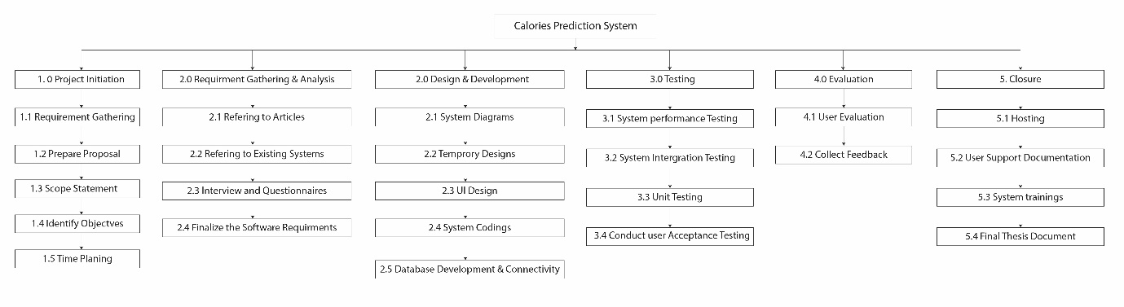

**Figure 1: WBS**

The primary work packages and tasks needed in constructing your web-based calorie burn prediction system are outlined in this Work Breakdown Structure (WBS). It encompasses the entire project, from early planning and requirement gathering to development, testing, data administration, user assistance, and maintenance. You can successfully plan, execute, and monitor progress throughout the project lifecycle by dividing the project down into manageable components.

# **Chapter2- Literature Review**

The goal of performing a thorough literature review for the "Web-Based Calorie Burn Prediction System" in the context of gym activities is multifaceted. For starters, it provides a solid platform for making informed decisions during the system's design and development phases. We obtain significant insights into the cutting-edge approaches, algorithms, and technologies used in the field of calorie burn prediction and fitness tracking by investigating existing studies. Furthermore, the evaluation of the literature allows us to comprehend the scientific ideas and discoveries that underpin calorie estimation during physical activities. This is very important for maintaining the correctness and dependability of our system. We may improve on earlier studies and research by combining the most recent breakthroughs and tested approaches into our system's algorithms. In addition, the review assists us in identifying industry best practices and benchmarks established by existing web-based fitness products. Analyzing successful systems and their user-centric characteristics allows us to improve the usability of our own system. As a result, our application closely matches the expectations and preferences of our target users.

## **Dependent and Independent Variables**

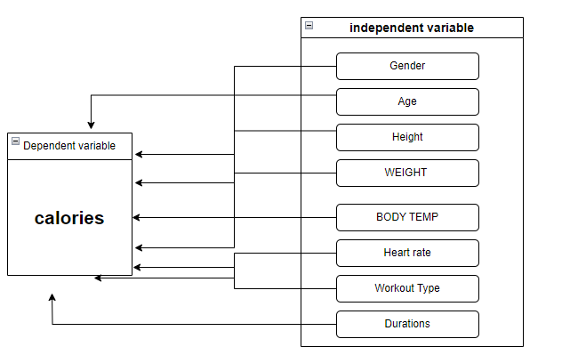

**Figure2: Conceptual Framework**

The conceptual framework of the project is intended to define the links and interactions between the dependent variable, "calories," and the independent variables, which include "gender," "height," "weight," "duration," "workout type," and "heart rate." The conceptual framework in this context outlines how these independent factors influence or correlate with the dependent variable. For- example, it will investigate how gender, height, and weight influence the quantity of calories burnt during a workout. It will also take into account the importance of parameters such as exercise duration, workout style, and heart rate on calorie expenditure. The goal is to create a clear understanding of how these variables interrelate and affect the accuracy of calorie burn prediction in the "Web-Based Calorie Burn Prediction System." By establishing these relationships, the project can develop more accurate and personalized algorithms for calorie estimation based on user-specific inputs.

* 1. **DEPENDANT VARIABLE**

1. In the year 2020, a group of Sona College of Technology students embarked on a ground-breaking project aiming at revolutionizing the way we track and manage daily calorie consumption. Several main aims drove this endeavor, which tried to solve the issues of monitoring nutrition and health in the setting of Indian cuisine. The fundamental goal of this endeavor was to create a unique algorithmic system that could not only gather but also reliably recognize photographs of meals. Furthermore, the students wanted to deliver precise nutritional data suited exclusively to Indian cuisines, recognizing the culinary landscape's distinctive richness and complexity. Furthermore, the system was created to categories these dishes based on the user's health needs, allowing users to make informed nutritional choices that fit with their particular well-being goals. The initiative relied on a comprehensive dataset that included information on calorie intake, food consumption habits, heart rate readings, and diabetes-related data to achieve these lofty goals. This plethora of information was critical in developing a comprehensive picture of an individual's health and nutritional habits. The technology enabled users to acquire insights into their food habits and their impact on overall health by integrating such data. Furthermore, the system went beyond simple data collection and processing. It actively helped users manage their calorie consumption by recommending ways to burn calories through physical activity or advising changes to their regular routines. This comprehensive approach to health and wellbeing transformed the system from a passive tracker to a proactive tool for promoting healthier lifestyles. The system's technical architecture was made up of two core elements. The first module used convolutional neural networks (CNNs), a form of artificial intelligence model, to classify and identify dishes from photographs. This method enabled the seamless recognition of a wide range of Indian meals, independent of their complexity or regional variances. The second module involved the creation of an Android application that functioned as the system's user interface. Individuals might use this app to effortlessly record photographs of their meals, receive instant nutritional information, track their calorie intake, and access personalized suggestions for maintaining a healthy diet and lifestyle. (Sathiya, et al., 2020)
2. Calorie Mama is a calorie-tracking programme that helps people manage their food choices and keep track of their calorie consumption. This software falls under the category of nutrition and calorie tracking apps, which are becoming increasingly popular among individuals attempting to live a healthy lifestyle. Calorie Mama's capacity to keep track of the items you consume and provide accurate nutritional information is one of its primary benefits. This covers not just the calorie count but also other important nutritional information such as protein, carbs, fats, vitamins, and minerals. This information can be quite useful for people who are conscious of what they consume and wish to make informed dietary decisions. Calorie Mama's use of image classification technologies to categorise food goods is a distinguishing feature. Simply take a photo of your meal, and the app will analyse it to provide nutritional information. This is especially handy when working with complex dishes or items that may not be easily found in a pre-existing database.Another noteworthy feature of Calorie Mama is its adaptability in terms of meal types. The software can suit your choices, whether you follow an international diet or enjoy Indian cuisine. It provides a variety of food options, making it appropriate for a diversified user base with varying dietary patterns.Azumi. Calorie Mama offers premium membership options for folks with specific weight loss goals. Premium customers have access to meal plans that are tailored to their specific goals, whether they want to gain, lose, or maintain weight. Individuals attempting to attain their fitness objectives may find these personalised strategies to be a beneficial resource.Keep in mind that, while Calorie Mama provides useful nutritional information and meal plans, it does not provide personalised health advice based on an individual's specific health situation. If users have special health issues or dietary limitations, they should get tailored dietary counsel from a healthcare practitioner. (Azumio, 2017)
3. "The Fat Secret app is an Australian-based tool for tracking diet and nutrition. Users must upload a picture of their meal and a label with their name on it in order to use this programme properly. After receiving this information, the programme displays the calorie content of the food item. Users can connect with peers on the platform and share their dietary intake. One of the most important aspects of this programme is the availability of food regimens meant to aid individuals in their weight loss quest. However, access to these diet regimens is not completely free; users must pay a charge for a premium membership to gain access to this option. Furthermore, the programme has a barcode scanner for packaged foods, which can detect these items and provide nutritional information. It should be noted that the barcode scanning capability does not work for packaged goods from India. Premium membership is also required for direct conversation with a dietitian via this service. The programme also supports users by providing information about the quantity of calories they have consumed, allowing them to keep watchful of their daily intake. While the programme is well regarded for its primary goal, it is largely meant to meet the needs of foreigners. As a result, it may lack adequate dietary recommendations or full nutritional information for all types of Indian cuisine. It’s worth noting that the program's database of foods and nutritional content does not rely on complex classification methods like deep learning. Instead, the program's architects adopted different approaches for classification and information provision. This factor may have an impact on the program's accuracy and completeness when it comes to specific types of foods, particularly ones that are not commonly consumed by its target user group. (Fatsecret, 2018)
   1. **INDEPENDENT VARIABLE**
4. In a 2013 study, Kooiman et al. sought to assess the precision of a specific web-based system developed to predict calorie expenditure during treadmill-based exercises. The major goal of this system was to provide users with information about how many calories they were burning while working out on a treadmill. The study's main finding was that the web-based method regularly overstated the number of calories burned during exercise by about 13.5%. In other words, when people used this approach to track their calorie expenditure, it frequently suggested that they had expended more calories than they had. The disparity between the system's calorie projections and the actual calorie burn witnessed in research participants cast doubt on the system's accuracy and efficiency. It was stated that the system might not be a viable tool for people looking for exact information regarding their calorie expenditure during treadmill activities. To explain this inaccuracy, the researchers suggested a theory. They proposed that including additional personalised and individualized data, such as heart rate information, might potentially improve the accuracy of the system's algorithm. Heart rate is an important indicator of an individual's effort and intensity during exercise, and it can provide more customized insights into calorie burn than generic estimations (Kooiman, et al., 2013)
5. In the year 2020, researchers began a project to quantify the calories burned during running activities. They used a single threshold technique accelerometer sensor, a cutting-edge technological equipment designed for precisely monitoring movement and activity levels, to accomplish this. The integration of this accelerometer sensor with a user-friendly mobile application distinguished this study. This programme was cleverly developed to harness the power of a common gadget that many people carry with them on a daily basis: the smartphone. This smartphone app was designed to act as a robust data-gathering tool for the study. The software capitalized on the shift in people's behavior when it comes to health and activity monitoring by leveraging the widespread adoption of mobile telephones with intuitive touchscreen displays. With their plethora of programmes and features, these devices have become a vital part of our daily lives, impacting how we track and engage in physical activity. The app's basic functionality was focused on monitoring and documenting physical activity. It accomplished this by meticulously tracking the number of steps taken and, more importantly, the calories burned during running sessions. The Android operating system's interoperability with the accelerometer sensor enabled this extensive data collecting. Android phones were outfitted with this advanced sensor technology, allowing them to calculate various physical activities precisely and consistently while running the Android operating system. Essentially, this study effort blended technology and human behavior. It used the capability of a touchscreen interface on a mobile smartphone and the precision of an accelerometer sensor to present users with significant data into their running habits. The resulting Android app acted as a useful and accessible tool for anyone wishing to track and improve their fitness levels by calculating the calories expended and steps completed during their runs. (Jefiza, 2020)
6. In 2022, a group of Amal Jyothi College of Engineering students began work on a project to develop a system capable of forecasting the number of calories an individual will burn during various forms of exercise. This project was motivated by a desire to investigate the capabilities of two different predictive machine learning algorithms as well as obtain insights into the calorie-burning tendencies of various exercisers. The study began with the collection of a large dataset, which contained information from over 15,000 exercise sessions. There was one major variable of interest in this dataset, which was the number of calories burned, as well as seven other descriptors or features that offered context and information about each exercise session. Details such as the type of exercise, duration, intensity, age of the exerciser, and other relevant parameters could be included in these descriptors. The students used a systematic technique to make the prediction system accurate and trustworthy. First, they used a piece of the dataset for training. This entailed teaching the machine learning algorithms the patterns and correlations between the descriptors and the calories burned using previous data. The ultimate goal was for the algorithms to be able to anticipate calorie burn based on the characteristics provided.----After completing the training phase, the students put the two predictive machine learning systems to the test. They used these algorithms to forecast calorie burn for a different set of workout sessions that the models had never seen before. They were able to examine the algorithms' prediction accuracy and reliability in real-world settings as a result of this. The students calculated the average absolute error to assess the performance of various algorithms. Across the test dataset, this error metric assessed the degree of the differences between projected and actual calorie burn values. A predictive model with a lower average absolute error was more accurate. Finally, after extensive testing and review, the students chose the machine learning model that predicted calorie burn with the highest accuracy. This model would serve as the cornerstone for their forecasting method for calorie burn. (Vinoy & Joseph, 2022)

## **2.3 MODERATING VARIABLE**

The individual's fitness level or experience could be a moderating variable in the context of the "Web-Based Calorie Burn Prediction System" project. The link between the independent factors (gender, height, weight, duration, workout style, and heart rate) and the dependent variable (calories burned during a workout) is moderated by this variable. Each of these independent variables can effect the quantity of calories burned differently depending on your fitness level or expertise. A very fit person, for example, may burn calories differently during an exercise than someone who is less fit.

## **2.4 UNDERLYING THEORY**

The fundamental idea behind the "Web-Based Calorie Burn Prediction System" project is based on research from a variety of domains, including exercise physiology, nutrition science, and data analysis. It is founded on the basic principles that control calorie burn during physical activities, which are regulated by characteristics like as gender, body composition, exercise intensity, and duration.A survey of important papers and research in these domains provides the project with a solid theoretical foundation. It covers a variety of issues, including calorie expenditure computation, the effect of different workout kinds on calorie burn, and the necessity of user-specific data in accurate projections. The review synthesises current knowledge and insights, allowing the project to incorporate the most recent scientific findings and best practises into the system's development.

## **2.5 GAPS IN LITERATURE REVIEW**

The literature analysis for the "Web-Based Calorie Burn Prediction System" project has shown some critical topics that need to be investigated further. One important gap in the existing research is the scarcity of studies addressing the integration of real-time heart rate data into calorie burn calculations. While heart rate is an important predictor of exercise intensity, it is currently underrepresented in calorie calculation models.Another significant gap is the user-centric component of fitness programmes. There has been little investigation into how user choices and feedback affect the accuracy and usefulness of calorie prediction algorithms. Understanding the impact of user engagement, user interface design, and social interaction elements on system success is an important yet understudied topic. Furthermore, the literature review emphasises the need for more research into the various types of workouts and their individual impacts on calorie expenditure. The majority of available research focuses on a few frequent activities, leaving knowledge gaps about the calorie burn dynamics of less prevalent exercises.These gaps highlight the significance of the "Web-Based Calorie Burn Prediction System" project, which aims to address these gaps in the literature by developing a system that integrates real-time heart rate data, emphasises user-centric design, and incorporates a wide range of workout types for more accurate and personalised calorie burn predictions.

## **2.6 HYPOTHESIS DEVELOPMENT**

With a direct comparison to the actual calorie expenditure as determined by indirect calorimetry, the web-based calorie prediction tool seeks to provide accurate estimations of the calories expended during exercise sessions.A research might be conducted with participants who use the online calculator to project their calorie burn during workouts in order to evaluate this idea. These participants could then go through indirect calorimetry to find out exactly how many calories they burned during their workout. As a result, it would be possible to compare the actual calorie expenditure as determined by indirect calorimetry with the anticipated calorie burn as predicted by the web-based application. In essence, the aim is to evaluate the correspondence between the predicted calorie expenditure by the online tool and the actual calorie expenditure as measured by indirect calorimetry.

**Is it feasible to estimate the number of calories burned using this method?**

This study's main goal is to assess the accuracy of machine learning methods for calculating calorie expenditure during physical activity. The dataset includes multiple independent variables, including age, body temperature, weight, height, exercise duration, and kind, as well as a dependent variable, the number of calories burned. All of these independent variables exhibit a strong association with the dependent variable. This shows that by using the appropriate machine-generated algorithms on the supplied data, the system can estimate the number of calories burned.

**Create a hypothesis based on the independent variables.**

Table 1 shows the hypothesis.

|  |
| --- |
| H1 - Reduced calorie expenditure is correlated with increased height.  H0 - A shorter stature is linked to a higher caloric expenditure. |
| Weight Hypothesis 1: Your calorie consumption lowers as your weight rises.  Weight Hypothesis 0: Your calorie expenditure rises as your weight falls. |
| H1 Duration - The more calories burned, the longer the duration.  H0 - The shorter the period, the lower the number of calories expended. |
| Type H1 Exercise - The more intensive the workout, the more calories expended.  Type H0 Exercise - The less calories burnt by mild activity, the better. |
| H1 - A higher calorie intake results from an elevated heart rate.  H0 Heart Rate - Less calories are burned when the heart rate is lower.  . |
| Body Temperature H1 - The higher your body temperature, the more calories you burn.  H0 Body Temperature - The lower your body temperature, the less calories you burn. |
| H1 - As people age, their caloric expenditure declines.  Age H0 - People who are younger generally burn more calories. |

The final output result will be unaffected if there is no correlation between the two sets of data, making the forecast inaccurate or incorrect.

# **Chapter3-Methodologies for Software Development**

## **3.1THEORITICAL FRAMEWORK**

Delivering a unique and notable outcome that advances the frontiers of our research field is the main goal of our strategy. Prioritizing thorough research and data analysis as the first steps in the development of new software is essential. These should be followed by a number of further phases before the design is turned into a usable software product. I have chosen one of the several well-known models that are available to help form our system. In addition, I decided to construct the system using the Agile Methodology.

**Agile Technology:** Offering people a framework for decision-making with the flexibility to make adjustments based on user input is the justification for using this strategy. Precision and efficiency are prioritised in agile software development, which also promotes teamwork and talent diversification. It makes it possible to quickly create and demonstrate functionality.

**Machine learning**: Machine learning algorithms are able to learn from large datasets that contain details about calorie consumption and physical activity, which enables the creation of precise models for estimating calorie expenditure. These algorithms may be easily incorporated into online platforms to provide users with tailored estimates of the number of calories they burn while exercising. It's critical to realise that the sort of data available for analysis affects the choice of a machine learning algorithm just as much as the precise task it must complete. The quantity and calibre of training data, feature extraction, hyperparameter tweaking, and other variables also have a big impact on how well machine learning models perform. Therefore, it is essential to carefully evaluate these factors when creating a machine learning-based system to produce calorie expenditure estimations for exercise, whether it's heart rate monitoring or exercise equipment.

**Regression analysis**: Based on exercise-related factors such as duration, intensity, and heart rate, statistical models can be developed to forecast calorie burn. These models can be used in the web-based solution to provide customers with precise calorie forecasts. Eventually, a precise and trustworthy web-based calorie prediction tool for cardiac or machine exercise can be constructed by combining these methodologies.

* 1. **POPULATION**

Adults are the primary target population for the Web-Based Calorie Burn Prediction System. The normal age range for this audience is 18 and over. The system is intended to meet the unique demands and interests of adult users who are concerned with fitness, physical activity, and calorie expenditure.

**Key Aspects of the Target Audience (Adults):**

* Age Group: Adults aged 18 and above who want to live a healthy lifestyle and track their physical activities.
* Individuals who participate in various forms of physical activity, such as running, cycling, swimming, and other fitness activities, are referred to as fitness enthusiasts.
* Health-Conscious Users: Individuals who are aware of their calorie intake and are curious about how their physical activities contribute to their overall health and fitness goals.
* Individuals Seeking Motivation: Those seeking a tool to assist them in setting and achieving fitness goals by tracking their calorie burn progress.
* Adults who are comfortable using web-based tools and technology for fitness tracking and monitoring are considered tech-savvy users.
* Users who like connecting with friends and sharing their fitness successes on social media sites are considered socially active.

## **RESEARCH APPROACH**

A systematic methodology or methodological framework used to organise, carry out, and evaluate research in order to accomplish particular goals is known as a research approach. In order to properly answer questions or handle issues, it directs researchers in choosing the best methodology, data collection strategies, and analysis tools.

**An appropriate research strategy for the project "Gym workout Web-Based Calorie Burn Prediction System"**

A mixed-methods research methodology might be appropriate for the "Web-Based Calorie Burn Prediction System" project. This strategy combines qualitative and quantitative research techniques to fully meet the project's goals and user requirements. Here's why it works well:

1. **User-Centered Approach:** The project's goal is to develop an intuitive fitness application. User preferences, requirements, and pain points can be successfully captured through qualitative research techniques like user interviews and questionnaires.
2. **Data-Driven Accuracy:** The development of precise calorie prediction algorithms requires the use of quantitative techniques such as data analysis and modelling. These techniques are founded on mathematical and scientific theories.
3. **Review of the literature:** obtain current information, research findings, and technical insights about calorie burn prediction, fitness tracking, and user-centric fitness applications, do a thorough literature analysis. This process aids in comprehending the present state of the art and locating research gaps.
4. **gathering and analyzing data**: Through user interactions and fitness tracking, get real-world data. To increase the prediction model's accuracy and the system's precision, analyze the data.
   1. **MEASURES AND INSTRUMENTS**

A variety of tools and metrics are used to gather and analyse data for the "Web-Based Calorie Burn Prediction System" project. These measurements and tools are crucial for gauging the usefulness of the system, receiving user feedback, and guaranteeing the precision and efficacy of calorie projections. The following are some crucial techniques and tools:

**1. Surveys and questionnaires**: These instruments are used to collect user requirements and feedback, to rate user happiness, and to comprehend user preferences for calorie estimation and fitness tracking.

**2.Heart Rate Monitors:** Heart rate monitoring devices or sensors are used to record real-time heart rate data while engaging in physical activity, offering helpful information for estimating the number of calories burned.

**3.Fitness trackers**: These tools are used to keep track of a variety of fitness data, such as the number of steps walked, the distance travelled, and the amount of time spent engaged in an activity.

**4.Interfaces for mobile and web applications** are being developed as part of the project. These interfaces will be used to create tools for user interaction, data entry, and feedback gathering for both mobile and web apps.

**5.Data Analytics and Statistical Tools**: In order to improve the calorie prediction model, user data, historical records, and workout parameters are processed and analysed using data analysis software and statistical tools.

To develop a precise and user-friendly calorie burn prediction system, these measures and tools are essential for data collecting, user interaction, and system performance.

* 1. **DATA COLLECTION**

In order to collect data for my project, I choose to use Google Forms. To collect useful data from users, this option requires creating online surveys using the Google Forms platform. We can effectively gather user input, preferences, and requirements related to fitness tracking and calorie prediction by creating user-friendly and accessible questionnaires. This method is practical and convenient for gaining essential insights to guide the project's progress because it has the benefits of ease of use, quick data collection, and the capacity to reach a large audience.

The visuals on the following page show the set of multiple-choice questions that were given to responders via Google Forms.

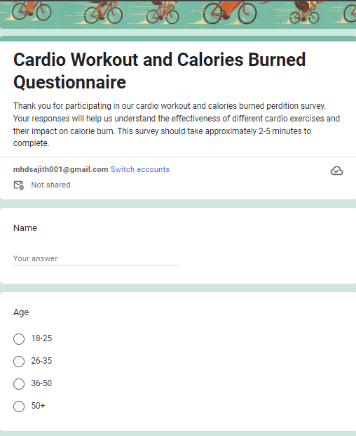

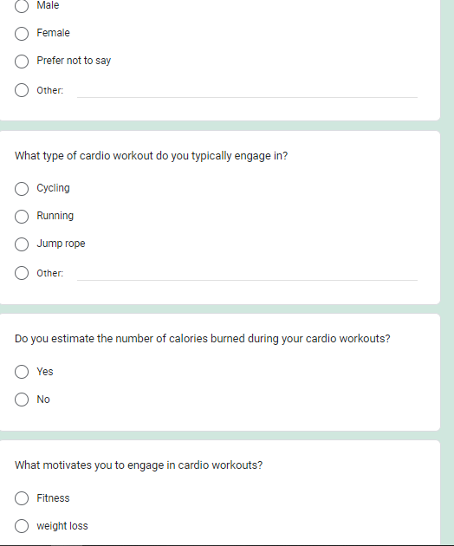

**Figure 3-Google form**

* 1. DATA ANALYSIS

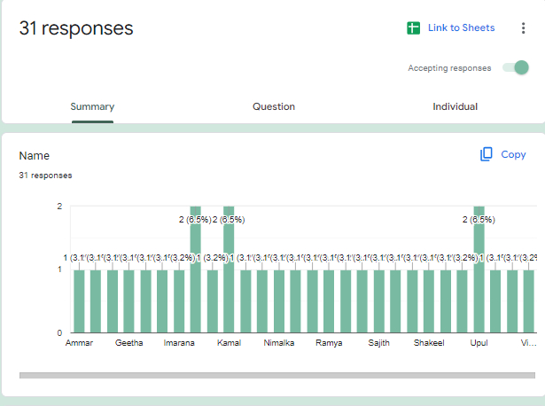

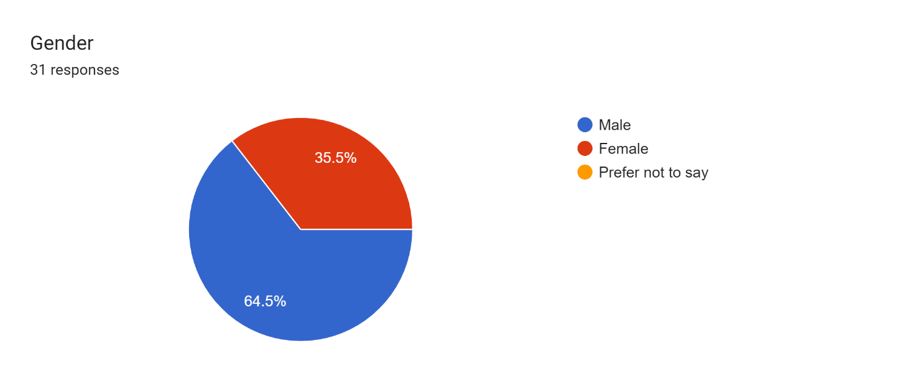

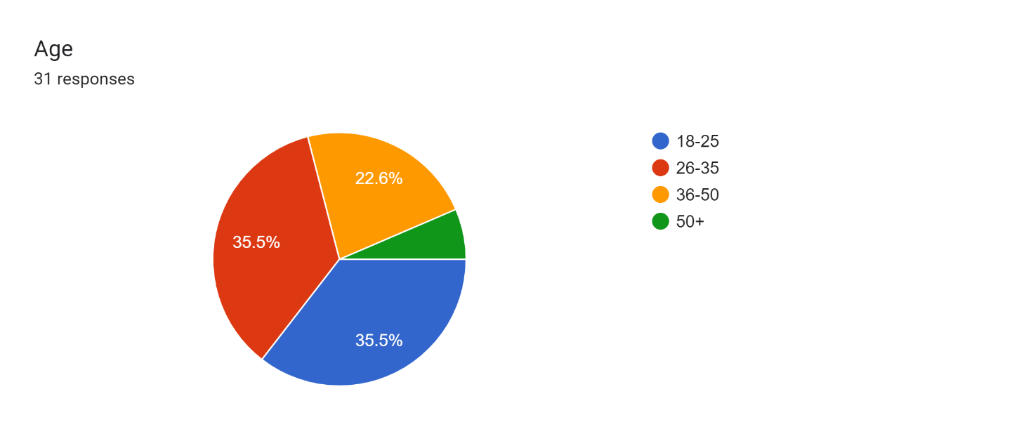

Forms response chart. Question title: Do you estimate the number of calories burned during your cardio workouts?
. Number of responses: 30 responses.

Forms response chart. Question title: What type of cardio workout do you typically engage in?
. Number of responses: 31 responses.

Forms response chart. Question title: What motivates you to engage in cardio workouts?
. Number of responses: 31 responses.

Our plan is on the right track, according to the information acquired during our information gathering meetings. The vast majority of those polled had favorable opinions of the method we're planning to create for predicting calories burnt. This response shows that there is a considerable interest in and demand for such a system among the people who were surveyed. The statistics also imply that respondents in our survey sample are receptive to changing to a new system if certain requirements are met. These criteria include delivering on the system's anticipated features and benefits, protecting the security of their personal data, and having appropriate functionality. That is to say, the respondents are open to the idea of a calorie burn prediction system and are willing to support it if it fits their requirements for functionality and data security.

This enthusiastic response from our target audience confirms the practicality of our concept and emphasizes the significance of producing a system that prioritizes user-friendly features and strong security measures in addition to properly predicting calorie burn. It shows that our product is in line with the requirements and preferences of the audience of potential users, which is encouraging for the success of the project.

# **Chapter 4 – Background of the Study**

## **4.1Why Is It?**

Kilocalories, or kcal for short, are another term for the unit of energy found in food. The body need food for survival, although the amount varies during the day for a variety of reasons. Calorie counting is a self-reporting method that estimates how many calories we consume each day. Setting a general daily calorie target (or maximum) and attempting to remain within it during the day are common components.

* 1. **What Is the Importance of It?**

Calorie counting is practiced for a variety of reasons. For those who are more interested in numbers, thinking about food in terms of calories is simple. Keeping track of calories appeals to people who want to know every detail about their food as well as those who are precise. Many people believe that calorie counting is more precise and provides them more control over their eating habits, lifestyle, and physical appearance. In some exceptional cases, medical advice recommends calorie tracking (typically in conjunction with nutritional monitoring).

* 1. **All User Requirements List**
* All regular users and administrators must log in.
* Calculate the number of calories burned.
* A calorie counter on the dashboard
* Setting reminders to remind everyone to keep track of their calorie intake.
  1. **EXPLANATION OF THE CURRENT SYSTEM**

By employing a calorie counting web application, there are methods that can calculate how many calories a person has burned. The user interface is frequently criticised by customers as being boring and uninspiring. The programme only considers a small number of factors, and according to my understanding, each individual may have different calorie needs. The current system, which is the first iteration of the "Web-Based Calorie Burn Prediction System," includes crucial elements including user identification, a registration procedure, a beautifully designed user interface (UI), and useful calorie burn projections. The following are the crucial elements and features:

1. **Registration and Login of Users:**

* The system allows new users to create an account by entering basic information such as their email address, username, and password.
* Registered users can safely check in with their credentials to have access to personalized features and data.

1. **UI (User Interface):**

* The system has a visually beautiful and user-friendly user interface that improves the user experience.
* Users may simply navigate the application, choose options, and enter data with minimal effort.

1. **Calorie Burn Estimation:**

* The system's main feature is its ability to anticipate calorie burn depending on user input.
* Users can choose specific physical activities, determine their length and intensity, and get precise calorie burn projections.

1. **Functional Forecasts:**

* The system generates calorie burn estimations based on proven algorithms or data sources, ensuring reasonable accuracy.
* Users can make informed decisions regarding their workout routines and calorie intake by relying on the system's forecasts.

### **Current System's Strengths:**

* User-Friendly UI: A well-designed user interface improves the user experience by making it simple for users to navigate and interact with the programme.
* Functional forecasts: The system's calorie burn forecasts are functional and accurate, giving customers important insights into their exercise routines.
* User Authentication: The processes of user registration and login contribute to security and personalisation.

**4.5 DREW BACKS OF THE CURRENT SYSTEM**

There may be a variety of drawbacks to using an online calorie estimate tool for exercise or machine exercise, including:

* **Inaccuracy:** Because The accuracy of the calorie estimate may be questioned because the prediction is based on statistical models and does not take into consideration a number of additional elements like heredity, health status, and environmental variables.
* **Poor personalization**: The calorie prediction tool may not be adequately personalised to provide accurate calorie projections for everyone because it only takes height, weight, and kind of activity into account. The tool might not account for individual variations in metabolism, exercise intensity, and other health concerns.
* **Limited exercise options:** The web-based programme might only offer a small selection of workouts, making it difficult to provide accurate calorie estimates for a variety of exercises.
* **Lack of professional guidance**: The web-based calorie prediction tool might not offer consumers expert guidance on eating plans, exercise routines, or other health-related topics, which might restrict its efficacy in enhancing general health and wellness.
  1. **EXPLANATION OF THE PROPOSED SYSTEM**

By addressing its limitations and bringing various new features and enhancements, the proposed system attempts to build on the present system's foundation, which includes user authentication, a user-friendly UI, and functional calorie burn projections. The following is an outline of the proposed system's primary components and functionalities:

1. **Better User Profiles:**Users can establish and manage detailed profiles that include personal information such as age, weight, height, heart details, gender, and exercise goals. This data will be used to precisely personalise calorie burn estimations.
2. **Progressive Algorithms and Data Sources:**

* For increased accuracy, the system will use modern calorie burn calculating algorithms and trusted data sources.
* Based on the most recent research and methodology, users should expect more precise calorie burn estimations.

1. **Integration with Wearable Devices:**The proposed system may integrate with popular fitness trackers and wearable gadgets, allowing users to seamlessly sync their activity data.
2. **Nutrition Monitoring (Optional):**Users may be able to measure their daily dietary consumption, providing a more comprehensive approach to health and fitness management.
3. **Personalized Suggestions:** The system can deliver personalised recommendations for physical activity and food choices based on user profiles, historical data, and fitness goals.

# **Chapter 5 –Feasibility Study and Requirements Gathering**

## **5.1 Feasibility Studies**

A first logical approach is essential since it necessitates the use of methodical approaches. Systems development and execution can make systematic use of the data and information gathered during the feasibility analysis. To create a risk assessment, both the positive and negative factors are methodically examined. The possible audience is also considered in addition to the market research. Before beginning the design process, it is determined whether the project has the potential for sustainable expansion. This makes sure that the decision or result strengthens the idea's plausibility.

### **5.1.2 COST FEASIBILITY**

The strategic decision to invest money in the creation of a system with the hope of recovering those costs after the system is implemented. It would be preferable if the system's productivity could be increased because that may increase revenue. It's important to recognise that this approach carries some inherent risks, most notably the chance of making the wrong investments in the wrong information system. The result might not be as advantageous as first thought. It is crucial to constantly perform cost analysis in order to reduce these risks and improve the overall efficacy of corporate operations. This analytical method is helpful in evaluating different investment prospects and options. An organisation can improve its financial decisions and, as a result, cut wasteful spending, which helps to lower operating expenditures, by routinely weighing these options. Cost analysis, in its essence, is essential to the wise use of financial resources, eventually assuring the success and viability of a project or commercial initiative.

|  |  |
| --- | --- |
| **Project Details** | **Price** |
| Proposal Ideas | Rs. 20,000 |
| both a hardware and software licence | Rs. 100,000 |
| maintaining and growing | Rs. 50,000 |
| Organising, Hosting, | Rs. 30,000 |
| Maintaining of the System | Rs. 35,000 |
| Promoting the System | Rs. 30,000 |
| **Total** | **Rs. 265000** |

* + 1. **Feasibility of Time Management**

In this particular situation, we often evaluate the limitations related to time to ascertain the duration required for developing the programs we generate, and whether they can be accomplished within a specific timeframe. It is imperative for the computer program to respond correctly within that timeframe. If the project isn't finalized and put to use as soon as possible, it will not succeed. We anticipate requiring approximately six weeks to complete the system.



**Time plan**

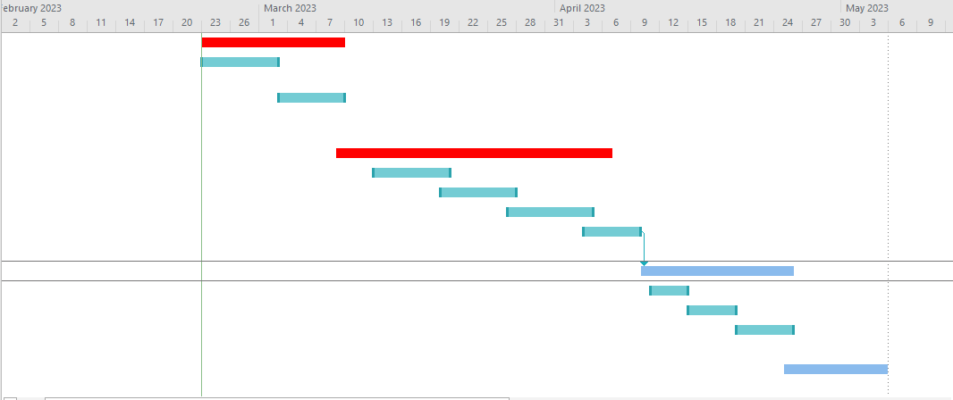

**Time plan Gantt chart**

My project, Web Based System for Gym Workout Calories Burnt Prediction, should be finished in one and half month. All project tasks, including planning, development, testing, and deployment are included in the schedule. To ensure that each assignment is finished on time and within budget, the project team will collaborate to complete each task. To make sure the project continues on schedule, we will frequently check progress against the timeline and make adjustments as needed.

I have allotted 11 days for this step-in order to make sure the project is well planned and thoroughly studied. I will gather requirements, explore pertinent technologies and tools, establish project goals, and create a thorough project plan within this period. Also, I will identify any potential risks or difficulties that might occur throughout the project and create backup strategies to deal with them. This phase's objective is to provide a strong foundation for the project and make sure it is ready to succeed. The project's development phase will last around 21 days. I'll concentrate on a variety of activities during this phase, including creating the user interface, gathering and getting ready the data needed for model training, putting the machine learning methods into practice, and optimizing the model for performance. As part of my thorough examination, I'll make sure the system is accurate and efficient. I will work with team members to keep the project on track and to make sure that all development tasks are finished by the due date throughout the development phase.

The project's testing and implementation phase, which will last about 21 days, is called Web Based System for Gym Workout Calories Burnt Prediction; The system will be thoroughly tested throughout this phase to make sure it functions as planned and adheres to all project requirements. This will entail running a variety of tests, including acceptance, integration, and unit tests. To ensure that the final product is of the highest caliber, any faults or problems that are found during testing will be immediately corrected. I will proceed to the implementation stage after the testing phase is finished, at which point I will deploy the system to production and make it accessible to end users. Additionally, I'll offer users the support and training they need to make the most of the system. In order to guarantee that the project is delivered on time and that all criteria are met, I will work collaboratively with team members and stakeholders throughout the testing and implementation process.

## **5.1.4 SCOPE FEASIBILITY**

Scope feasibility evaluates the system's ability to address problems in an efficient manner, investigate potential benefits noted in the project's original scope, and satisfy the specifications created during the system's development phase. We are adding new features that give the gym a variety of cutting-edge capabilities as we continue to expand our web-based system. These include the capacity to predict caloric expenditure, keep tabs on caloric intake, and deliver alerts to encourage caloric monitoring. The system's current flaws are planned to be fixed by the inclusion of these additional functionalities.

### **5.1.5 Technical Feasibility**

Undoubtedly, a web-based system for anticipating calorie intake is feasible. It could even combine with cardio or workout equipment. Using easily accessible technology that can be smoothly incorporated into current exercise equipment, this system would be capable of monitoring and collecting exercise-related data such as heart rate, speed, incline, and resistance. We shall examine the technological features that this system offers in this review. It enables This Company to assess the efficiency of the technological resources and the technical team's capability to translate these concepts into useful, functional solutions. We will go over the most important things to think about in this situation below.:

1. **Stack of Technology:**

* Evaluation: The suggested technological stack must be technically possible to implement, including frontend and backend technologies, databases, and any third-party connectors.
* Consider whether the chosen technologies are scalable and maintainable in relation to the project's requirements.

1. **Development Knowledge:**

* Evaluating whether the project team holds the technical competence required to properly implement the planned system and features.
* Consider training or hiring team members with the required expertise to fill any skill gaps.

1. **Maintenance and Support:**

* Consider the system's ability to be maintained and supported beyond its first deployment.
* Consider: Plan for ongoing maintenance, upgrades, and user assistance to keep the system effective and secure.

1. **Budget and Resources:**

* Evaluation: Determine the budget and resources required for technological development and continuous operations.
* Take into account: Make sure the project is appropriately funded and has access to the necessary technical resources.

## **5.2 Requirements Gathering**

### 5.2.1 SELECTING THE SUITABLE FACT GATHERING TECHNIQUE

To avoid surprises for stakeholders (such as software engineers, managers, clients, and so on), it is critical that everyone involved in the project understands their common goals. If the outcome has any unexpected plot twists, it will be bad news for such sellers. To appropriately collect information from the customer, evaluate what can and cannot be finished, and design methods after considering the client's perspective and checking the final papers with them, we must establish ways. All of these factors may lead to a thorough and accurate description of our clients' requirements, which would surely contribute to the construction of a final product that meets their expectations.

### **5.2.2** **FACT GATHERING USING SELECTED TECHNIQUES– Questionnaire**

I choose to collect information through surveys since it has various benefits. Surveys enable us to obtain data from a huge number of individuals fast, making them a more accessible tool. Participants can easily offer their responses and comments to the questions posed. Furthermore, surveys save time because they eliminate the need for one-on-one interviews, making it a more efficient procedure.it is critical to carefully construct the questionnaire to ensure that it matches with the system's objectives. I've developed a series of questions that I believe will be really useful in getting replies from the vast survey audience. These questions are strategically intended to elicit the information required to effectively accomplish the project's aims.some example Questionnaire in blow:

* Name
* Age
* Gender
* Do you estimate the number of calories burned during your cardio workouts?
* What type of cardio workout do you typically engage in?
* What motivates you to engage in cardio workouts?

## **5.2.3 REQUIREMENTS DETERMINATION**

### 5.2.3.1 CORE REQUIREMENTS:

The core requirements are the main features and capabilities required for the effective creation and operation of the "Web-Based Calorie Burn Prediction System." These requirements are crucial to attaining the core aims of the project

* **.User authentication:** Registered users must first create a profile on the site and gain user authorization before using the calorie estimation function.
* **Calorie Prediction Algorithm:** "The system must have a calorie estimation algorithm, which is in charge of figuring out how many calories a person burns when exercising. This algorithm will consider a number of factors, such as the user's heart rate, the volume, intensity, and length of the workout. The system will analyse these variables to accurately anticipate the number of calories burned, giving users insightful information about their fitness development.
* **Customised Recommendations (Reminder**): Based on the user's goals and workout data, the system should give personalised recommendations for them, such as instructing them to stick to a specific training routine or lower their calorie consumption.
* **Data Visualisation** (Generate Report): The system should provide easy and interactive data visualisations to help users understand their daily physical activity and calorie burn over time

### 5.2.3.2 SECONDARY REQUIREMENTS:

Secondary needs are additions and enhancements that can improve the user experience and add value to the system but are not fundamental to its primary functionality. Based on available resources and user feedback, these requirements might be prioritized.

* **Accuracy**: The system should provide precise calorie calculations with a minimal margin of error based on the user's exercise data.
* **Reliability**: In order to provide users with continuous access, the system should be dependable, with little downtime and maintenance requirements.
* **Security**: To protect user data, the system must have effective security features such as user authentication and personal data encryption.
* **Usability:** The system should have simple interfaces, clear instructions, and be easy for users to use..
* **Scalability:** As the user base grows, the system should be scalable enough to serve a large number of users and a growing volume of data.
* **Performance**: The system should respond swiftly and load pages quickly even during busy periods.

## **5.2.4 RESOURCE IDENTIFICATION**

### 5.2.4.1 Hardware Requirements

* Core i5 Processor
* Any Graphics Memory from Intel
* A Monitor
* A Network Connection (LAN/WLAN)
* A Mouse and a Keyboard
* 4GB RAM
* 40GB SDD Storage

### 5.2.4.2 Software Requirements

* Draw oi
* VS Code
* PhpAdmin
* PyCharm
* Google Collab

## **THE SOFTWARE PROCESS MODEL**

**Agile Model for the "Web-Based Calorie Burn Prediction System" Project**

The Agile paradigm is preferred for the "Web-Based Calorie Burn Prediction System" because it provides a flexible and user-centric approach to software development. Given the dynamic nature of fitness and customer preferences, Agile enables us to collect and incorporate user feedback on a constant basis, adapt to changing requirements, and deliver incremental improvements. This keeps the system sensitive to user needs, resulting in a more effective and gratifying user experience. The project's goal of establishing a web-based system that grows in response to user expectations and changing fitness trends combines nicely with Agile's emphasis on collaboration and iterative development. Here's an explanation of how the Agile methodology can be used in this project:

**1.Iterative and incremental growth:**

* Agile development takes place in small, incremental increments. This means that features and enhancements will be developed and delivered in small, manageable iterations for this project.

**2.Ongoing Feedback:**

* Agile encourages stakeholders, especially users, to provide constant input. This is consistent with the project's goal of being user-centric. Surveys, interviews, and user testing can all be used to collect user feedback.

**3.Adaptability and Flexibility:**

* Agile is extremely adaptive to changing needs. As the project continues and user feedback is gathered, changes to the system's features and priorities can be made to better match user needs.

**4.Adjustable Planning:**

* Agile planning is adaptable, allowing for changes to the project plan as new insights emerge. This strategy is useful in a project where user requirements may change over time.

**5.Design for the User:**

* Agile places a premium on user demands and happiness. It enables the rapid implementation of user-requested innovations and enhancements, resulting in a system that closely matches user expectations.

In summary, the Agile approach is well-suited to the project "Web-Based Calorie Burn Prediction System" since it provides a framework for iterative development, frequent user feedback, and the flexibility to adapt to changing needs and user preferences.

# **CHAPTER 6: DOMAIN INVESTIGATION**

## 6.1 DECISION SUPPORT TOOLS

Software programmes or systems known as "decision support tools" give people or organisations the data, analysis, and insights they need to make wise decisions. By gathering, organising, and presenting data in a way that simplifies difficult scenarios and helps choose the best course of action, these technologies are intended to support the decision-making process.A variety of activities are available with decision support tools, including data analysis, modelling, forecasting, and visualisation. They can be used to support both strategic and operational decision-making in a variety of industries, including business, healthcare, finance, and many more. These tools assist decision-makers in weighing various possibilities, taking into account the possible outcomes of their decisions, and finally arriving at well-informed choices that are supported by data-driven insights.

### Why it is important

* **Algorithm Development:** The development and improvement of calorie prediction algorithms is aided by decision support systems. With the help of a variety of factors, including heart rate, user profiles, and type of exercise, these technologies can analyse enormous datasets, spot patterns, and fine-tune the algorithm.
* **Processing of Real-Time Data:** The system depends on real-time data from users, such as heart rate, biometric data, and exercise data. These data can be processed in real-time by decision support tools to deliver precise and timely estimations of calorie burn.
* **Personalization:** A significant component of the system is the ability to provide personalized fitness advice. Decision support technologies leverage user data analysis to deliver individualized workout and dietary suggestions, enhancing the user experience.
* **User Feedback Analysis:** To find system improvement opportunities, decision support technologies can examine user feedback and usage trends. This guarantees that customer feedback and concerns are taken into account when the system is updated.
* **data security:** Ensuring the safety of user data is essential. By spotting potential weaknesses and assuring compliance with data protection laws, decision support systems assist in monitoring and maintaining data security.
* **Resource Allocation Optimization**: Decision support tools can help with resource allocation by examining usage trends and feature uptake. The project team can then focus its development efforts on the features that will have the biggest effects on user happiness and system performance.
* **Continuous Improvement:** Tools for decision assistance allow for continual system improvement. They can pinpoint the places where the system fails to live up to user expectations and direct iterative development to fix these flaws.
  + 1. **DECISION THEORY**

Making reasonable judgements in the face of risk or uncertainty requires the application of the mathematical and analytical framework known as decision theory. The project's feature prioritisation, algorithm development, and resource allocation can all be supported by decision theory in the context of the "Web-Based Calorie Burn Prediction System" initiative. The following are a few crucial elements of decision theory and how they apply to the project:

1. **Making Decisions in Uncertain Situations:** When the results of each choice are unpredictable, decision theory offers strategies for making decisions. Uncertainty in the project could result from user behavior, different types of workouts, or the precision of calorie prediction models.

**2.Utility and Results:** In decision theory, evaluating the utility or value of various outcomes is key. The project's definition of utility includes both system performance and user satisfaction.

**3. Risk Assessment:** Risks connected with various decisions can be assessed using decision theory. For instance, it can assist in determining the risk associated with introducing a particular feature or using a particular algorithm to calorie predictions.

**4. Decision Standards**: Decision criteria are developed to assess and contrast various possibilities. Accuracy, user happiness, and resource efficiency are possible project criteria.

**5.Desired Value:** A key idea in decision theory is expected value, which is used to evaluate the possible effects of various decisions. It can be used in the project to evaluate the anticipated benefits of adding particular features or selecting particular algorithmic options.

**6.Sensitivity analysis,** Sensitivity analysis is frequently used in decision theory to examine how changes in variables or assumptions affect decisions. This might be helpful when evaluating the effects of elements like user feedback and algorithm precision.

**7. Optimization and Trade-Offs:** Finding trade-offs and maximising choices are made easier with the aid of decision theory. For the project, this may entail striking a balance between user features and development resources or between algorithm complexity and accuracy.

**8.Tools for Decision Support**: In order to facilitate decision-making, decision theory frequently makes use of decision support tools and strategies. These tools can be applied to the project to prioritise features, allocate resources, and optimise the system.

The "Web-Based Calorie Burn Prediction System" project can make well-informed choices regarding algorithm development, user-centric features, and resource allocation by using decision theory principles and methodologies, ultimately resulting in a more efficient and user-friendly fitness application.

### **6.1.3 DECISION TREE**

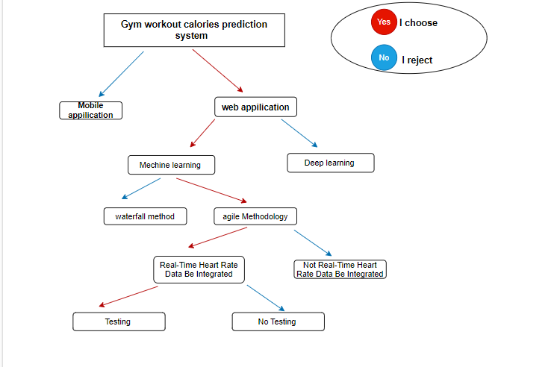

The decision tree of the "Gym Workout Calories Prediction System" starts with the selection of the main platform. The development emphasis swings away from a mobile application if a web application is chosen. Selecting the development strategy follows the decision. By choosing machine learning instead of deep learning, the process is made simpler and opens the door for data-driven predictions.The flexibility and user feedback that come with the Agile methodology are prioritised over the rigidity of a waterfall approach. The decision tree also provides the option of incorporating real-time heart rate data to improve forecasts. If used, this feature might produce outcomes that are more accurate. The decision tree also takes into account the value of testing in the creation process to guarantee a high-quality final result.

This decision tree provides a methodical way to choose the project's direction, coordinating the development process with certain options and considerations in the building of the "Gym Workout Calories Prediction System."

## **TECHNICAL RESEARCH**

Technical research is the methodical examination and analysis of certain technical or scientific topics with the goal of advancing knowledge, resolving real-world issues, or creating new technologies. In a specialised subject, it frequently entails extensive investigation of ideas, procedures, experiments, and data analysis. Technical research strives to deepen our grasp of technical ideas, advance current technology, or develop fresh approaches to technical problems.

* **Algorithms for Accurate Calorie Estimation During Different Physical Activities:** Research into the Development and Improvement of Algorithms for Accurate Calorie Estimation During Different Physical Activities. This could include data-driven strategies, predictive analytics, and machine learning models.
* **The utility of heart rate monitoring technologies**, such as wearable gadgets, in improving the accuracy of calorie burn forecasts is being studied. The incorporation of real-time heart rate data into calorie calculation models could be the subject of this study.
* **Research on user profile methods** that tailor calorie burn forecasts by taking into account variables like age, weight, height, fitness goals, and fitness background. Investigate the effect of customised profiles on forecast precision.
* **Machine learning for Predictive Analysis**: Research on machine learning models and methods to increase the precision of estimates of calorie burn. This could include approaches for feature selection, model training, and evaluation.
* **Database Design and Management:** Investigate methods for effectively storing and retrieving user profiles and past fitness data in databases. scalability, indexing, and normalisation of data considerations.
* **Examine the technological ramifications** of including social interaction components into the system, such as gamification, user engagement analytics, and interface with social networking platforms.
* **Technical study aimed** at improving the system's performance, such as server-side performance, reaction times, and reducing data latency for real-time functionality.

# **Chapter 7 – Design**

The foundational stage of the application process is design. In essence, it's an excellent and original thought experiment that opens the door to a carefully considered strategy for achieving the goals outlined in the required research phase..

## **System Design - Architecture**

**Use Cases Diagram**

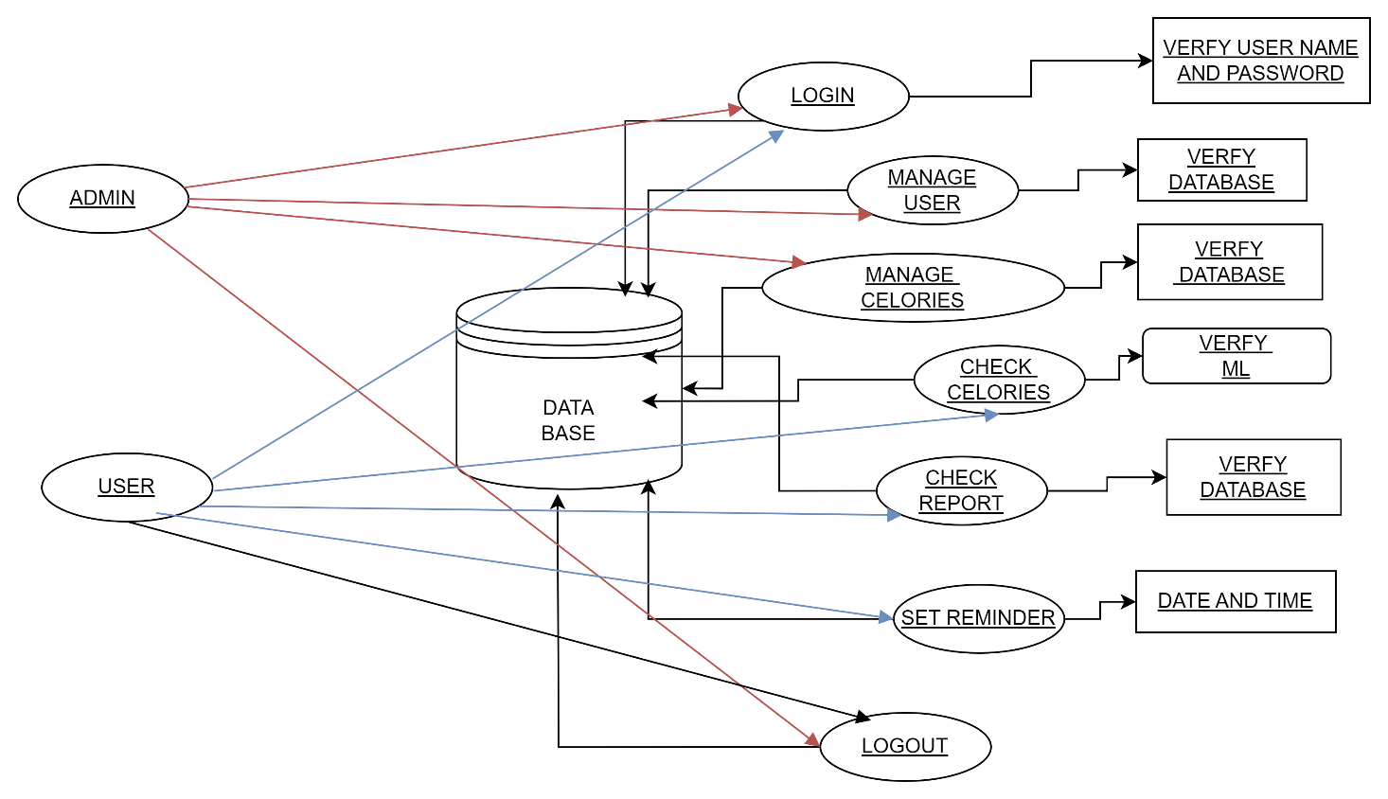

Use-case diagrams and UML diagrams are comparable in that they both serve the same goal. They are a useful tool for determining the core needs and goals that direct their usage. These visual representations emphasise the considerable impact that these interactions have on the client by highlighting the interactions between a client and a class function.In essence, these diagrams give a clear understanding of how the system works from the viewpoint of the customer, illuminating how it operates and the effects it has on the client's experience..

**Sequence Diagram**

"Behavorial UML diagrams are significant in the creation of software products because of their obvious simplicity and importance during the design stage. These diagrams are effective tools for demonstrating how various components of a software system, such as actors and classes, interact and relate to one another. In essence, they offer a visual representation that clarifies the dynamic features of a system and provides information on its behaviour and the connections that control its operation. In essence, behavioural UML diagrams are a crucial tool in the software development process because they offer a systematic and understandable way to comprehend how a software system functions.

1. **Login Sequence Diagram**

**Figure 4: Login Sequence Diagram**

1. **User Registration Sequence Diagram**

**Figure 5: Registration Sequence Diagram**

1. **Calories Sequence Diagram**

**Figure 6: Calories Sequence Diagram**

**Class Diagram**

**Figure 7: Class Diagram**

**Context Diagram**

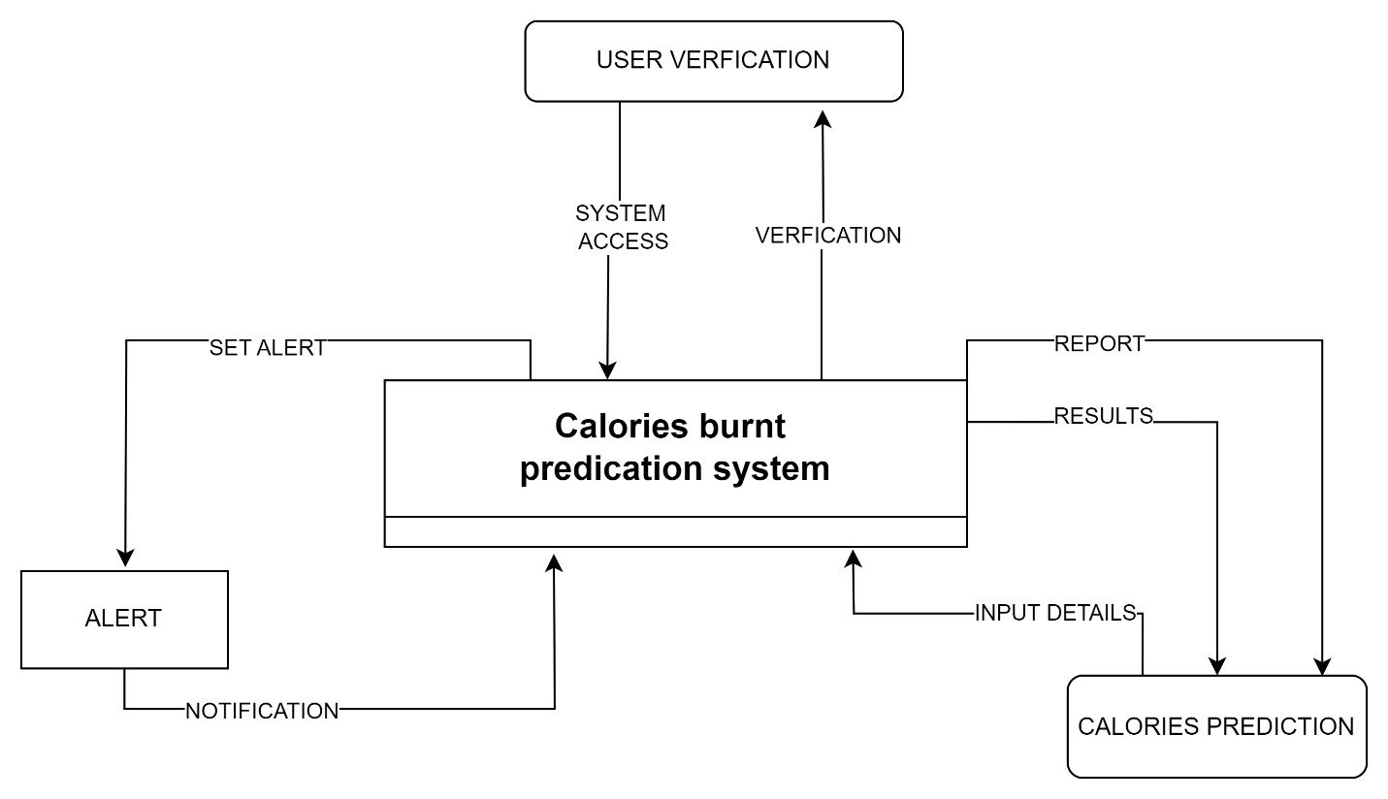

**Figure 9: Context Diagram**

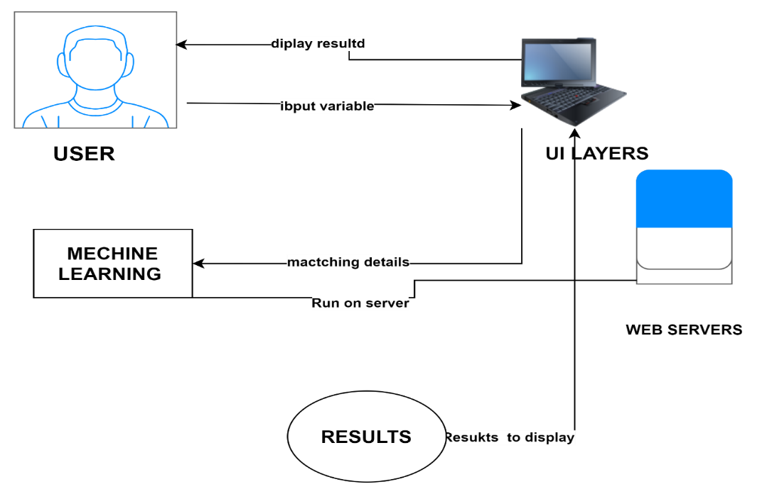**Context Diagram – Graphical**

**Figure 10: Graphical Context Diagram**

**2. Mockups / Wireframes UI**

In basically, a wireframe is a notional, early representation of a website's design. As a rough draught, it offers a basic visual framework that can be quite helpful when presenting concepts to clients or as a visual assistance for explanations. I first created a prototype for these ideas using a programme called Draw io. I then made alterations and changes to the prototype in response to particular standards and specifications that had been established throughout the development process.



**Figure 11: Home Wireframe**



**Figure 12: Login Wireframe**



**Figure 13: Registration Wireframe**



**Figure 14: Result Wireframe**

**Figure 15: Prediction Wireframe**



## **7.3 Database Development**

phpMyAdmin is an open source, free database management application that can be used to handle the administration of tables and data within a MySQL database. This software is praised for its adaptability because it can function flawlessly on a variety of operating systems and server setups. The database management procedure is greatly simplified by its user-friendly graphical user interface, which is one of its distinguishing qualities. Some conditions must be satisfied for phpMyAdmin to function properly. These involve setting up MySQL, PHP, and the Apache web server. However, it's important to point out that XAMPP, a software package, easily contains all of these necessary parts. As a result, XAMPP was selected as the preferred option for building and maintaining the database since it simplifies the setup process by including all the required tools in a single package.

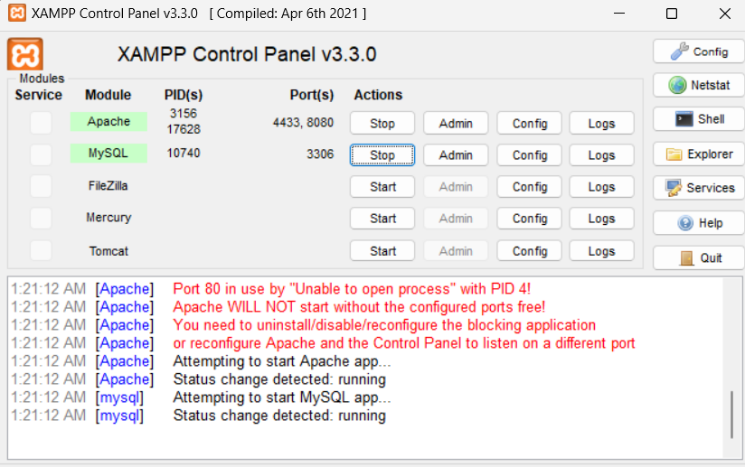

**Figure 16: XAMPP Server**

**Coding for Database Connection**



**Registered Details**

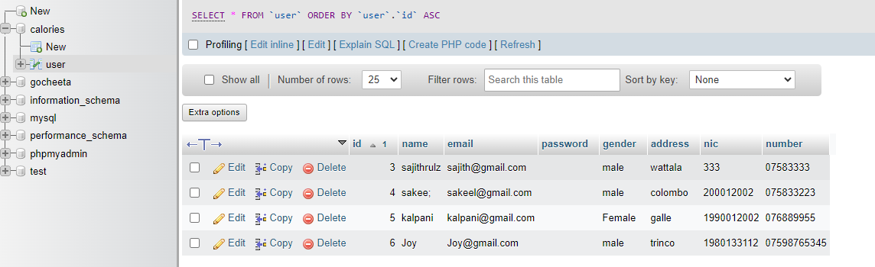

**Database Table Details**

### **7.3.1 Entity Relationship – ER Diagram**

|  |  |  |  |
| --- | --- | --- | --- |
|  |  |  |  |
|  |  |  |  |
|  |  |  |  |
|  | |  | | --- | | **Figure 8: ER Diagram** | | | |

# **Chapter 8 – Implementation**

Setting up a web-based calorie prediction tool for cardio or machine activities involves several steps.

* The creation of a user-friendly interface that enables consumers to input their fitness statistics properly is crucial. Included in this information should be specifics like the amount of time spent exercising and its intensity. To guarantee that this interface is simple to use and effective within the system, it must then go through extensive development and testing.
* A machine learning technique should be used by the system to forecast how many calories will be burned based on the user's input. For training and fine-tuning, a sizable amount of workout data and related calorie burn data will be needed to make sure this algorithm operates as well as it possibly can. To improve the predictability of calorie burn, it will be essential to collect this comprehensive dataset.
* In order to guarantee that the system effectively determines calorie burn for a variety of exercise activities and for people with a variety of physical features, it is crucial to rigorously validate the technique. This validation procedure is essential to ensuring that the system can accurately estimate how many calories are burned during various types of activity and for individuals with diverse body types.

.

## **System Implementation**

Python and JavaScript were used for a well-organized and successful system implementation.

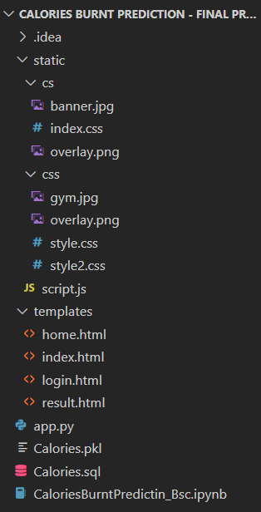

**Figure 28: Implementation Folder**

**Figure 31: Implementation Code 2Figure 28: Implementation Folder**

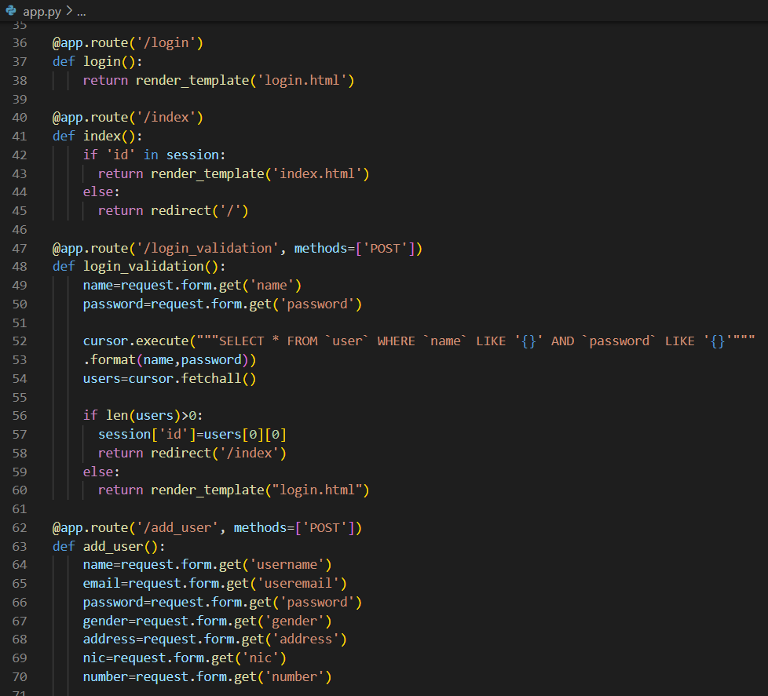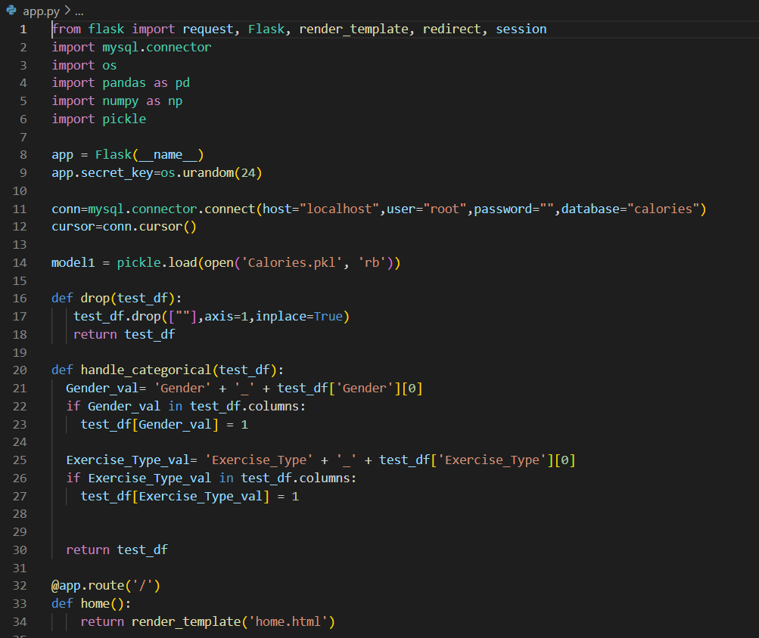

**Figure 34: Implementation Code 1**

**Figure 35: Implementation Code 4Figure 36: Implementation Code 1**

**Figure 37: Implementation Code 4**

**Figure 38: Implementation Code 3Figure 39: Implementation Code 4Figure 34: Implementation Code 1**

**Figure 35: Implementation Code 4Figure 36: Implementation Code 1**

**Figure 37: Implementation Code 4Figure 34: Implementation Code 1**

**Figure 35: Implementation Code 4Figure 36: Implementation Code 1**

**Figure 37: Implementation Code 4**

**Figure 38: Implementation Code 3Figure 39: Implementation Code 4Figure 34: Implementation Code 1**

**Figure 35: Implementation Code 4Figure 36: Implementation Code 1**

**Figure 31: Implementation Code 2**

**Figure 35: Implementation Code 4Figure 36: Implementation Code 1**

**Figure 37: Implementation Code 4**

**Figure 38: Implementation Code 3Figure 39: Implementation Code 4Figure 34: Implementation Code 1**

**Figure 35: Implementation Code 4Figure 36: Implementation Code 1Figure 31: Implementation Code 2**

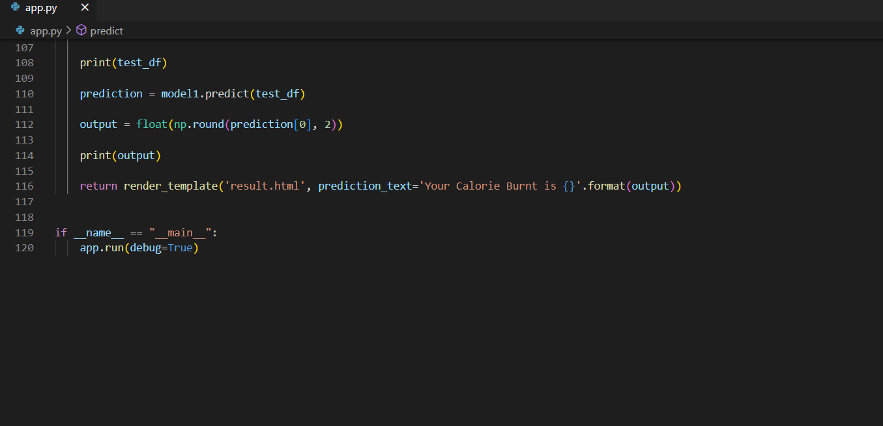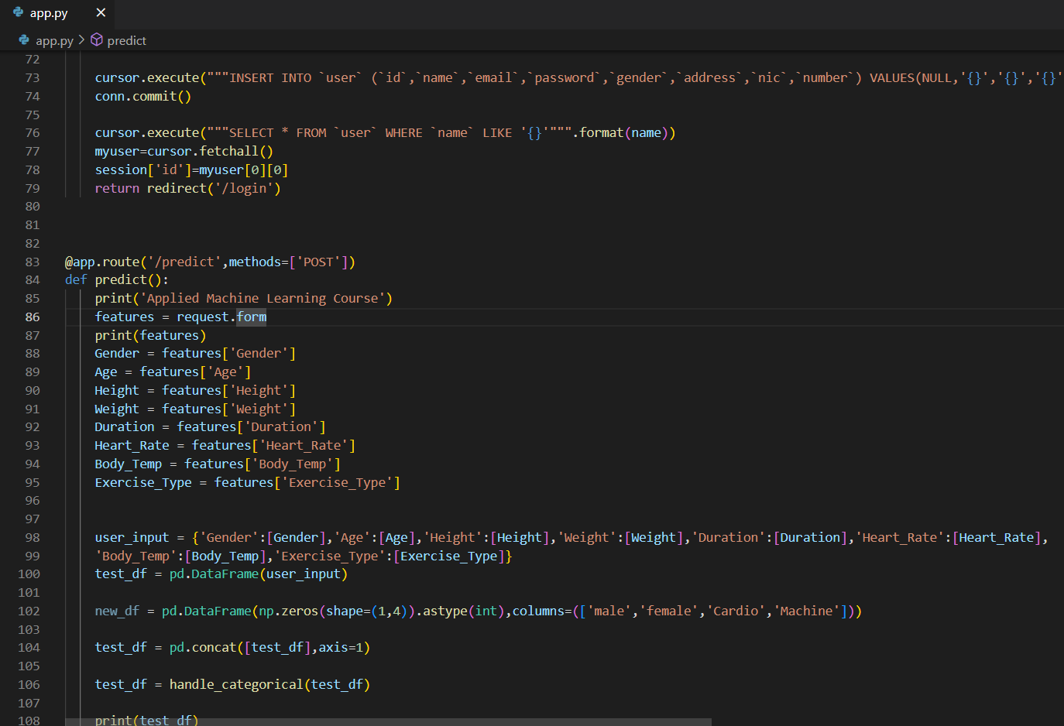

**Figure 40: Implementation Code 3**

**Figure 41: Home Page UIFigure 42: Implementation Code 3**

**Figure 43: Home Page UI**

**Figure 44: Home Page CodeFigure 45: Home Page UIFigure 40: Implementation Code 3**

**Figure 41: Home Page UIFigure 42: Implementation Code 3**

**Figure 43: Home Page UI**

## **UI Implementation**

HTML, CSS, JavaScript (JS), and jQuery were used to develop the system's user interface. The result of this evolution is depicted in the screenshot.

**Home Page UI**

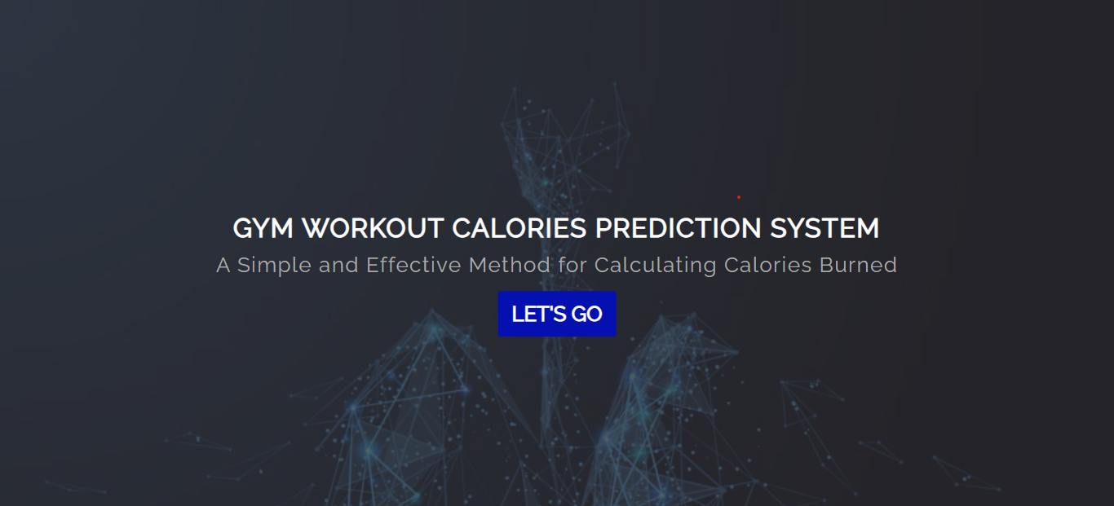

**Figure 43: Home Page UI**

**Figure 44:**

**48: Home Page CodeFigure 43: Home Page UI**

**Figure 44: Home Page CodeFigure 45: Home Page UI**

**Figure 46: Home Page Code**

**Figure 47: Login Page UIFigure 48: Home Page Code**

**Figure 49: Login Page UI**

**Figure 50: Registration UIFigure 51: Login Page UIFigure 46: Home Page Code**

**Figure 47: Login Page UIFigure 48: Home Page Code**

**Figure 49: Login Page UI**

**Figure 50: Registration UIFigure 51: Login Page UI**

**Figure 52: Registration UI**

**Figure 53: Registration / Login UI CodeFigure 54: Registration UIFigure 49: Login Page UI**

**Figure 50: Registration UIFigure 51: Login Page UIFigure 46: Home Page Code**

**Figure 47: Login Page UIFigure 48: Home Page Code**

**Figure 49: Login Page UI**

**Figure 50: Registration UIFigure 51: Login Page UIFigure 46: Home Page Code**

**Figure 47: Login Page UIFigure 48: Home Page Code**

## **Login / Registration Page UI**

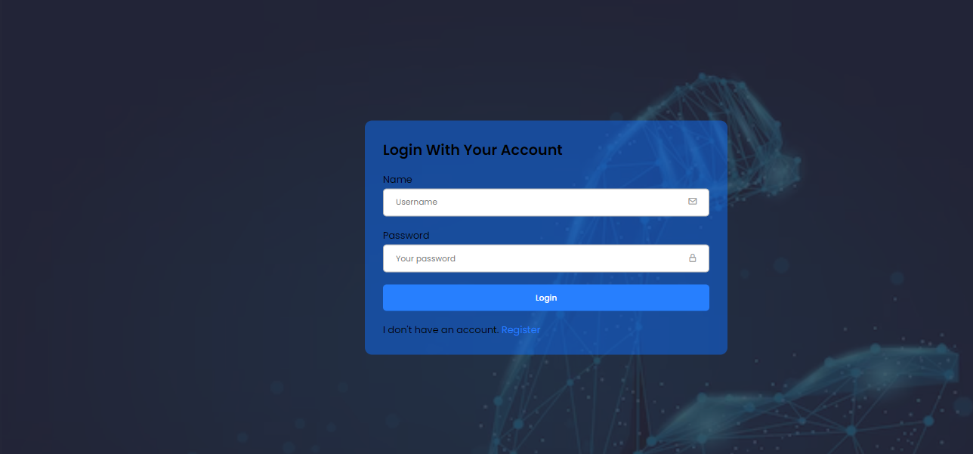

**Figure 49: Login Page UI**

**Figure 50: Registration UIFigure 51: Login Page UI**

**Figure 52: Registration UI**

**Figure 53: Registration / Login UI CodeFigure 54: Registration UIFigure 49: Login Page UI**

**Figure 50: Registration UIFigure 51: Login Page UI**

**Figure 52: Registration UI**

**Figure 53: Registration / Login UI CodeFigure 54: Registration UI**

**Figure 55: Registration / Login UI Code**

**Figure 56: Prediction PageFigure 57: Registration / Login UI CodeFigure 52: Registration UI**

**Figure 53: Registration / Login UI CodeFigure 54: Registration UIFigure 49: Login Page UI**

**Figure 50: Registration UIFigure 51: Login Page UI**

**Figure 52: Registration UI**

**Figure 53: Registration / Login UI CodeFigure 54: Registration UIFigure 49: Login Page UI**

**Figure 50: Registration UIFigure 51: Login Page UI**



**Figure 52: Registration UI**

**Figure 53: Registration / Login UI CodeFigure 54: Registration UI**

**Figure 55: Registration / Login UI Code**

**Figure 56: Prediction PageFigure 57: Registration / Login UI CodeFigure 52: Registration UI**

**Figure 53: Registration / Login UI CodeFigure 54: Registration UI**

**Figure 55: Registration / Login UI CodeFigure 52: Registration UI**

**Figure 53: Registration / Login UI CodeFigure 54: Registration UI**

**Figure 55: Registration / Login UI Code**

**Figure 56: Prediction PageFigure 57: Registration / Login UI CodeFigure 52: Registration UI**

**Figure 53: Registration / Login UI CodeFigure 54: Registration UI**

**Figure 55: Registration / Login UI Code**

## **Prediction Page UI**

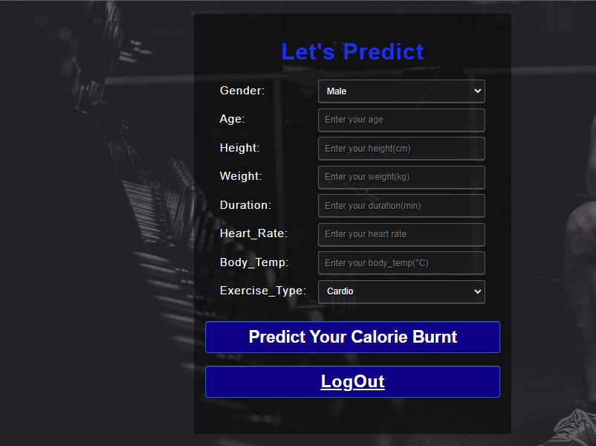

**Figure 58: Prediction Page**

**Figure 61: Prediction Page UI Code**

## **Result Page UI**



**Figure 64: Result Page UI**

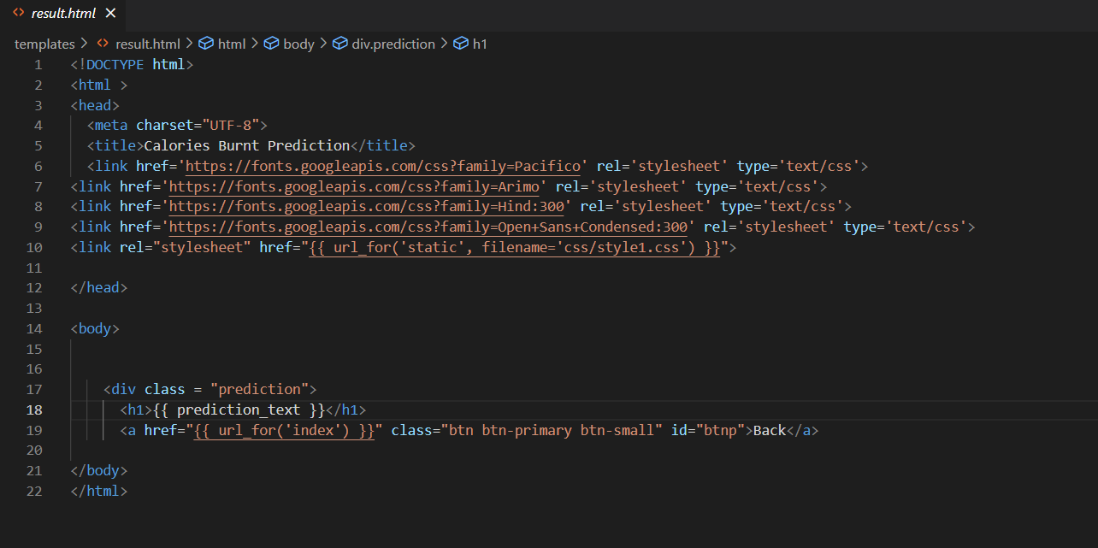

**Figure 67: Result Page UI Code**

**Figure 68: Dataset AnalyzingFigure 69: Result Page UI Code**

**Figure 70: Dataset Analyzing**

**Figure 71: Correlation HeatmapFigure 72: Dataset AnalyzingFigure 67: Result Page UI Code**

**Figure 68: Dataset AnalyzingFigure 69: Result Page UI Code**

**Figure 70: Dataset Analyzing**

**Figure 71: Correlation HeatmapFigure 72: Dataset Analyzing**

**Figure 73: Correlation Heatmap**

**Figure 74: Training the DatasetFigure 75: Correlation HeatmapFigure 70: Dataset Analyzing**

**Figure 71: Correlation HeatmapFigure 72: Dataset AnalyzingFigure 67: Result Page UI Code**

**Figure 68: Dataset AnalyzingFigure 69: Result Page UI Code**

**Figure 70: Dataset Analyzing**

**Figure 71: Correlation HeatmapFigure 72: Dataset AnalyzingFigure 67: Result Page UI Code**

**Figure 68: Dataset AnalyzingFigure 69: Result Page UI Code**

## **4. Model Implementation**

In order to estimate the overall number of calories burned during a workout session, I used the random forest regression approach. The person's gender, age, height, weight, exercise duration, body temperature, heart rate, and the activity they engaged in were all taken into account while making this forecast. The random forest approach is a potent technique that can handle classification and regression tasks with equal efficacy. This is achieved by aggregating several decision trees using a process called bagging, also known as bootstrap aggregation. The core idea underlying random forests is to use numerous decision trees collectively rather than just one to make decisions. When you need to create predictions using a dataset with a variety of attributes, this method is extremely helpful. In random forests, the learning process entails building a large number of decision trees, each of which offers a distinctive viewpoint on the data. We produce trial datasets by statistically picking rows and characteristics from the source dataset before building each decision tree within the random forest. Individual decision trees are then trained using these trial datasets. We can improve prediction accuracy and handle intricate relationships in the data by combining the findings from these trees.

.

**Diagram of Workflow**

This programme so distinguishes itself from other ones by concentrating primarily on data gathering and analysis with the aim of forecasting the number of calories burned throughout an individual's workout. Users will be able to utilise the mobile application that the model drives to determine the number of calories they've burned once it has been fully developed, using the app's established parameters as a starting point for calculation.

## **Dataset Details**

**Table 3: Dataset Details**

|  |  |
| --- | --- |
| **Features of Dataset** | **Functions of Dataset** |
| Gender | Male or female |
| Age | Age must appear in the current year. |
| Height | Height should be in cm |
| Weight | User should weigh in kilos. |
| Duration | Where the Minutes should be mentioned |
| Heart Rate | Average heart rates during activity (greater than 60 beats per minute) |
| Body Temperature | Over exercise, the human body temperatures |
| Exercise Type | What kind of workout is performed? |
| Calories | total number of calories expended during exercise |

**Dataset Analyzation and Correlation**

**Figure 70: Dataset Analyzing**

**Figure 71: Correlation HeatmapFigure 72: Dataset Analyzing**

**Figure 73: Correlation Heatmap**

**Figure 74: Training the DatasetFigure 75: Correlation HeatmapFigure 70: Dataset Analyzing**

**Figure 71: Correlation HeatmapFigure 72: Dataset Analyzing**

**Figure 73: Correlation Heatmap**

**Figure 70: Dataset Analyzing**

**Figure 71: Correlation HeatmapFigure 72: Dataset Analyzing**

**Figure 73: Correlation Heatmap**

**Dataset Training and Testing (Model)**

**Figure 76: Training the Dataset**

**Figure 77: Testing the DatasetFigure 78: Training the Dataset**

**Figure 79: Testing the Dataset**

**Figure 80: Testing the DatasetFigure 76: Training the Dataset**

**Figure 77: Testing the DatasetFigure 78: Training the Dataset**

**Figure 79: Testing the Dataset**

**Figure 76: Training the Dataset**

**Figure 77: Testing the DatasetFigure 78: Training the Dataset**

**Figure 79: Testing the Dataset**

**Figure 80: Testing the DatasetFigure 76: Training the Dataset**

**Figure 77: Testing the DatasetFigure 78: Training the Dataset**

**Figure 79: Testing the Dataset**

**Figure 79: Testing the Dataset**

# 

# **Chapter 9 –TESTING**

## 9.2 TEST PLAN AND TEST CASES

For this project, my preferred method is manual testing. We can thoroughly check and confirm the functionality of the product through manual testing. You can quickly evaluate the extensive test plan and specific test cases that describe our testing technique and guarantee a complete evaluation of the system. This approach guarantees a high degree of precision and accuracy in assessing the functionality and usefulness of the product.

**TEST PLAN**

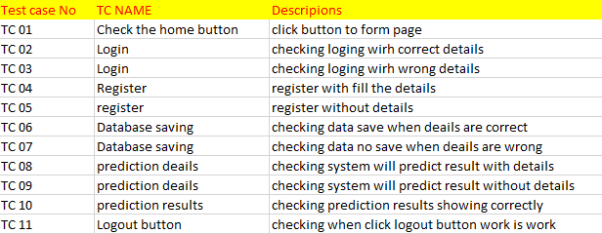

The test plan includes a number of test cases, each of which is intended to assess a different component of the system. These test cases cover user interface, data handling, and prediction accuracy functionality. They comprise tests for the registration procedure with and without accurate information, the database data saving, the outcomes of predictions, and the effectiveness of the logout button. The system is thoroughly tested to satisfy its goals, give accurate predictions, and offer a seamless user experience thanks to its extensive set of test cases. Each test case relates to a particular user interaction or system feature, and the effectiveness and overall quality of the system depend on how well each test case is carried out.

**TEST CASE**

|  |  |
| --- | --- |
| Test Id | TC01 |
| DESCRIPIONS | click button to form page |
| EXPECTED RESULTS | SUCCESSFULLY WORK |
| ACTUAL RESULTS | PASS |
| SCREENSHOT |  |

|  |  |
| --- | --- |
| Test Id | TC02 |
| DESCRIPIONS | checking logging with correct details |
| EXPECTED RESULTS | SUCCESSFULLY WORK |
| ACTUAL RESULTS | PASS |
| SCREENSHOT |  |

|  |  |
| --- | --- |
| Test Id | TC03 |
| DESCRIPIONS | checking logging with wrong details |
| EXPECTED RESULTS | NOT WORKING |
| ACTUAL RESULTS | PASS |
| SCREENSHOT |  |

|  |  |
| --- | --- |
| Test Id | TC04 |
| DESCRIPIONS | register with fill the details |
| EXPECTED RESULTS | Successfully WORK |
| ACTUAL RESULTS | PASS |
| SCREENSHOT |  |

|  |  |
| --- | --- |
| Test Id | TC05 |
| DESCRIPIONS | register without details |
| EXPECTED RESULTS | NOT WORKING |
| ACTUAL RESULTS | PASS |
| SCREENSHOT |  |

|  |  |
| --- | --- |
| Test Id | TC06 |
| DESCRIPIONS | checking data save when details are correct |
| EXPECTED RESULTS | Successfully WORK |
| ACTUAL RESULTS | PASS |
| SCREENSHOT |  |

|  |  |
| --- | --- |
| Test Id | TC05 |
| DESCRIPIONS | checking data not save when details are wrong |
| EXPECTED RESULTS | NOT WORKING |
| ACTUAL RESULTS | PASS |
| SCREENSHOT |  |

|  |  |
| --- | --- |
| Test Id | TC08 |
| DESCRIPIONS | checking system will predict result with details |
| EXPECTED RESULTS | Successfully WORK |
| ACTUAL RESULTS | PASS |
| SCREENSHOT |  |

|  |  |
| --- | --- |
| Test Id | TC09 |
| DESCRIPIONS | checking system will predict result without details |
| EXPECTED RESULTS | NOT WORKING |
| ACTUAL RESULTS | PASS |
| SCREENSHOT |  |

|  |  |
| --- | --- |
| Test Id | TC09 |
| DESCRIPIONS | checking when click logout button work is work |
| EXPECTED RESULTS | WORKING SUCCESSFULLY |
| ACTUAL RESULTS | PASS |
| SCREENSHOT |  |

# **Chapter 10 – Critical Evaluations & Conclusion**

## **10.overweview of maintain**

After the entire system has been built and deployed, the final stage of the software development life cycle is system maintenance. Once a system is operational, it frequently needs continuing upkeep. Simply said, the software runs for a considerable amount of time after installation and needs continuous maintenance to guarantee that the final product consistently performs at its highest level of performance. Throughout the application development process, skilled programmers provide coding support, suggesting solutions in line with business goals, detecting system problems for users, and resolving potential security threats. In order to keep the system functioning as planned and providing long-term value, developers solve any issues as they arise during the maintenance phase.

**1. Release and Deployment Schedule**

The structure is prepared to be deployed and made accessible for use inside the live system once it has passed through the steps of planning, development, implementation, and evaluation. Customers and users can access this web-based application as long as they have internet connectivity and are utilising equipment that complies with the project's specifications, such as web browsers like Google Chrome or Microsoft Edge. After the system's development is complete, an administrator will be made and assigned to the concerned client. The ability to use the programme for business operations will be granted to this administrator..

**2. System Supply and Assistance**

According to the feasibility assessment, users may encounter a few difficulties while attempting to use or operate the system; as a result, training on the basic technical abilities required to use the device is critical. To streamline the process and provide effective maintenance assistance to the customer, it is generally desirable to share the workload of client requests and concerns on the development side.

**3.Maintaining Hardware**

Making sure that all of a computer system's physical parts, including servers, storage units, and networking gear, stay in top operating order is known as hardware maintenance. To avoid hardware failures, this calls for routine checks and repairs. More specifically:

* Check servers for any signs of wear and tear because they are crucial to managing and distributing resources and services. To keep them functioning properly, regular cleaning, cooling system upkeep, and replacement of worn-out parts are necessary.
* In order to identify possible problems like data corruption or disc failures, storage systems, including hard drives and data storage devices, must be continuously monitored. Regular inspections and the confirmation of data integrity are essential elements of storage system hardware maintenance. To ensure smooth data flow throughout the network, networking hardware like routers and switches should be maintained. This includes inspecting for physical damage or cable faults, monitoring for firmware updates, and keeping an eye on network congestion.

**4.Software maintains**

The process of continuously managing and updating a computer system's numerous software components is referred to as software maintenance.

* Applying the most recent security patches, bug fixes, and software upgrades made available by software providers constitutes updating and patching the system's software components.
* To maximise efficiency and preserve compatibility with other system components, software libraries, frameworks, and applications must be updated and maintained on a regular basis.

**5.Data maintain**

The integrity and accessibility of the data contained within the system are the fundamental concerns of data maintenance. It entails procedures designed to maintain the accuracy and completeness of data. Here is a more thorough justification:

* Routine data validation checks are used to find and fix mistakes, inconsistencies, and missing data in databases or data repositories in order to ensure data accuracy and completeness.
* To protect against data loss due to unintentional deletion, system failures, or security breaches, it is essential to have reliable data backup and recovery protocols. Data maintenance requires regular backups and the testing of recovery methods.
* **User managing -"**Managing user access, rights, and accounts inside a system is known as user administration. This entails maintaining user accounts in their entirety as well as controlling who has access to the system, what they are able to do, and who can use it. Reviewing user activity logs on a regular basis is essential to maintaining the system's security since it allows you to spot and stop any unauthorised or unpleasant access.
* **Performance maintenance**-On the other side, performance maintenance entails ongoing monitoring of different system metrics like response time, effectiveness, and resource usage. This procedure guarantees that the system is performing at its best. To ensure that the system is operating at maximum efficiency, performance must be regularly assessed. When necessary, tweaks and optimisations should be performed. To maintain the system's high level of performance and functionality, this process entails the assessment and improvement of numerous elements, such as reaction times, resource allocation, and overall productivity.

**Conclusion** "Regular system maintenance is crucial to the efficiency and functionality of the web-based exercise calorie prediction tool, whether for cardio or machine workouts. This crucial procedure makes sure the system runs as efficiently as possible, lowering the likelihood of downtime and potential hazards of data loss, security breaches, and other issues that might have an adverse effect on the user experience.

## **10.1. Summary**

This project's main goal is to investigate how machine learning approaches can be used to calculate how many calories are burned during an exercise. In the context of this work, our initial focus is on the creation of a machine learning system that can calculate the number of calories burned during exercise. People are becoming more concerned with the effectiveness of their workout routines, food decisions, and the measurement of calories expended after exercise in today's fitness-conscious society. We want to apply machine learning strategies, such as the incorporation of Linear and XGB regressors into web apps, to increase user engagement with our system. With this context, the following project report will thoroughly explain the full system creation process. An overview of project organization will be given at the outset, and it will then move on to the steps of requirement analysis, system design, system implementation, testing, and, finally, post-release maintenance and support. The report will also include other crucial sections that go into a variety of topics, from extensive background research to conceptual design sketches.

## **10.2. Evaluation**

In addition to meeting other project objectives, the generated system first satisfies the needs of the desired end user and is in line with the main project goal of developing a reliable, approachable, and affordable calorie expenditure prediction tool. Individuals can access results based on their input by logging in to the website using the specified credentials. Additionally, this system provides previously restricted features like calorie tracking and reminder setting. The superuser or administrator of the platform, who is given complete power upon enrolment, can effectively run the programme. This system emphasises user interaction, efficiency, and long-lasting performance and is available to anybody with internet connection and a web browser.

## **10.3 Limitation of the system**

* This operating system is not suitable for every user.
* For the system to give accurate results, correct data entry is required.
* An active internet connection is required.
* Incorrect user input will cause the system to behave abnormally.
* The unpopular system for which it was designed.

## **10.4. Future enhancements**

* A mobile application for Android
* Significantly expand the dataset to improve calorie detection accuracy.
* Enhance the user interface by including a calories graph that graphically depicts daily calorie changes.
* Take pictures of your meals and count the calories they contain.
* to improve the system by incorporating features for calculating additional parameters such as nutrition.
* reaching a weight-loss goal.
* Guidance on how to gain or lose weight based on calorie consumption.
* Send a reminder to the software.
* Data should be stored in databases.

## 10.5 LESSONS LERANED REPORT

The process of creating this calorie forecasting software taught us numerous important insights. The significance of empowering customers through user-friendly interfaces cannot be emphasized in the first place. A significant takeaway included the application of specialized machine learning methods to compute and offer accurate calorie information. The importance of calorie management in upholding a healthy lifestyle became clear, emphasizing the demand for effective tools to aid in this endeavor. Unique and fascinating experiences characterized the project's development process, highlighting the importance of adaptability and ongoing progress. User feedback and efficient project management strategies both proved crucial for platform optimization. Working with cutting-edge systems and technologies demonstrated how important it is to stay current with market trends. The experience also reaffirmed the value of developing project management abilities for both professional and personal advancement, laying a solid basis for future endeavors.

## **10.6. Conclusion**

The main goal of this thesis is to empower customers by giving them access to an intuitive and user-friendly platform that will allow them to precisely forecast their calorie expenditure. We used a very special machine learning technique to properly calculate and include calorie information into a website in order to accomplish this. In order to have a healthy and active lifestyle, calorie control has become increasingly important. It can take a lot of time and effort to keep up a balanced diet and create a nutrition plan that suits each person's tastes. This platform's development was characterised by a number of unique, unusual, and exciting experiences. With the help of deft project management techniques and intelligent user input, we discovered numerous chances to improve the framework. Collaboration with other cutting-edge technologies and systems was essential to the success of this project. Learning project management approaches was essential for developing our professional skill set because the existing organisation used similar strategies. To sum it up, I have learned a lot from working on this project, and I know that these talents will come in handy in the future.

# **Chapter-11 REFERENCE**

## References

Azumio. (2017). *A snap to get started & it's easy to lose weight*. Retrieved September 1, 2022, from https://www.azumio.com/apps/calorie-mama/overview

Fatsecret. (2018). Retrieved September 1, 2022, from https://www.fatsecret.com/?frc=True

Jefiza, A. (2020). *The Calorie Burning Calculation System in Jogging Using a Thresholding-Based Accelerometer Sensor*. Retrieved September 1, 2022, from https://www.researchgate.net/publication/341762638_The_Calorie_Burning_Calculation_System_in_Jogging_Using_a_Thresholding-Based_Accelerometer_Sensor

Kooiman, T. J., Dontje, M. L., Sprenger, S. R., Krijnen, W. P., van der Schans, C. P., & de Groot, M. (2013). Reliability and validity of ten consumer. *BMC Sports Science, Medicine and Rehabilitation, 5*(1), 25.

Krebs , P., & Duncan, D. (2019). *Health App Use Among US Mobile Phone Owners: A National Survey*. Retrieved September 18, 2022, from https://pubmed.ncbi.nlm.nih.gov/2637656/

Kumar, D. (2021). *Mobile Health Application*. Retrieved September 18, 2022, from https://www.sciencedirect.com/topics/computer-science/mobile-health-application

Sathiya, Surya, P., Thirukkumaran, & Vijaiarivalagan. (2020). PREDICTION OF USER’S CALORIE. *International Journal of Engineering Applied Sciences and Technology, V*(3), 189-195.

Vinoy, S., & Joseph, B. (2022). *Calorie Burn Prediction Analysis Using XGBoost Regressor*. Retrieved July 16, 2022, from file:///C:/Users/user/Downloads/Calorie%20Burn%20Prediction%20Analysis%20Using%20XGBoostRegressor%20and%20Linear%20Regression20Algorithms.pdf

## APPENDIX A: TEST CASES WITH RESULTS

|  |  |
| --- | --- |
| **Test case Id** | **Results** |
| TC 01 | **Pass** |
| TC 02 | **Pass** |
| TC 03 | **Pass** |
| TC 04 | **Pass** |
| TC 05 | **Pass** |
| TC 06 | **Pass** |
| TC 07 | **Pass** |
| TC 08 | **Pass** |
| TC 09 | **Pass** |
| TC 10 | **Pass** |

## **APPENDIX B**: **USER MANUAL**

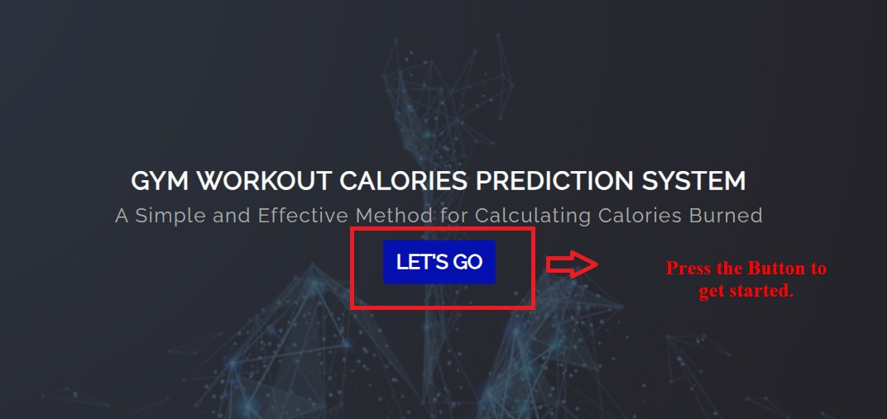

**When you're ready to start, simply click the "Let's Go" button in the user manual.**

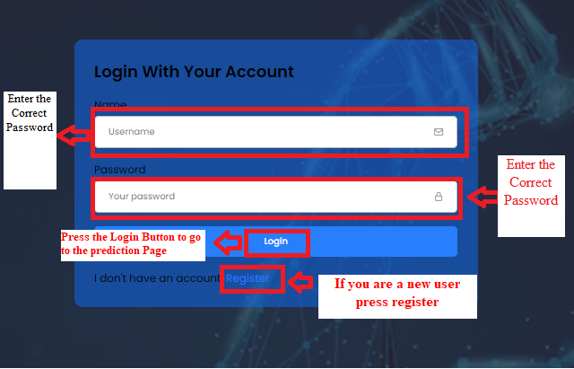

**Please provide the correct email address and password in order to utilise this user manual. Next, select "login" to begin anticipating an activity. By selecting the "register" button, you can open an account if you don't already have one.**

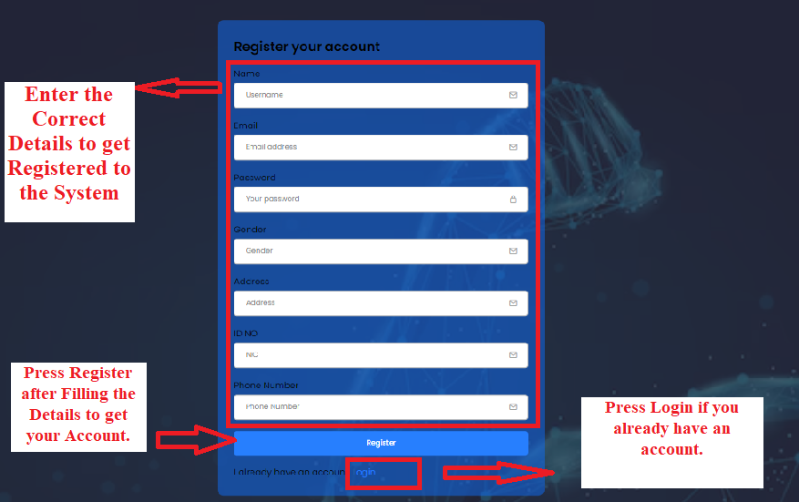

**You must complete the required fields before clicking the "Register" button to establish your account. Your account will be created as soon as you complete it. After that, click "Login" to move on to the following step.**

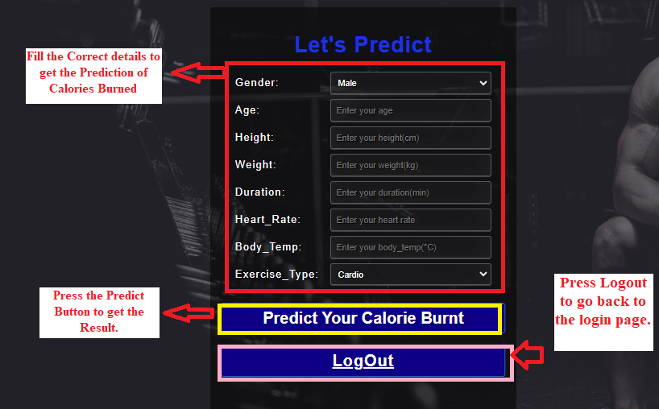

**After logging in, you will see the prediction page, which resembles the image. You should enter the correct data before pressing the "Prediction" button to see your findings in order to get accurate results.**

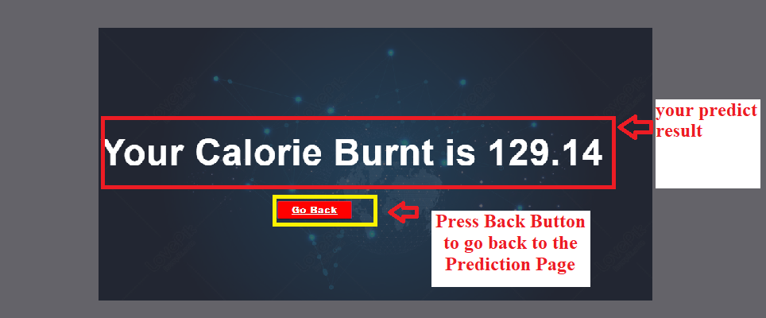

**Once you've successfully entered all the information, you can now review the outcomes. Simply click the "Go Back" button to return to the previous page. It's that simple!**

## **APPENDIX C: PROJECT LOG SHEETS**



**Logsheet-01**



**Logsheet-02**



**Logsheet-03**



**Logsheet-04**



**Logsheet-05**